Land, Public and Private
Land use concepts and classification
Human land use affects the environment in many ways
These activities have negative consequences, as we have already discussed:
- Logging may lead to mudslides
- Deforestation leads to climate change, etc.
- Change in landscape is the #1 reason for species extinction
- Paving over land divert water runoff and they create “heat islands”
- Overuse of soil can lead to soil degradation and water pollution
Tragedy of the Commons:
The tendency of a shared, limited resource to become depleted because people act from self-interest for short-term gain.
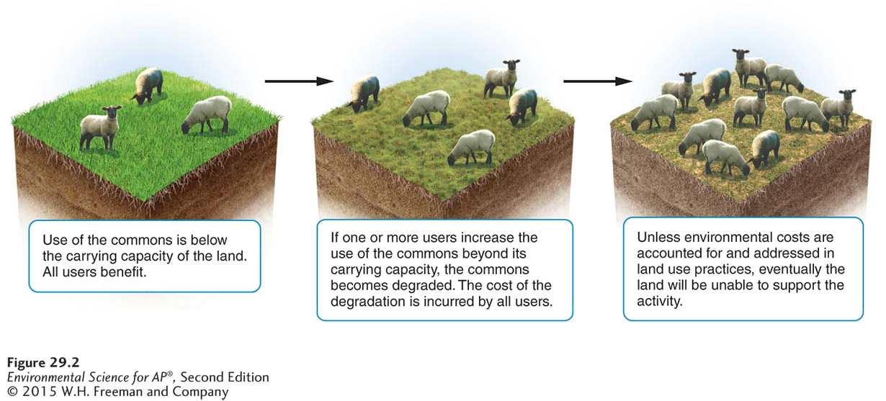
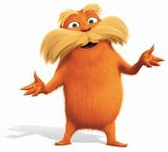
We will watch the Lorax (for educational purposes, of course) to further reiterate the tragedy of the commons.
The tragedy of the commons is the result of an economic phenomenon called a negative externality. An externality is the cost or benefit of a good or service that is not included in the purchase price of that good or service.
Example: If you live above a bakery and wake up every morning to the smell of fresh-baked bread, you are benefitting from a “positive externality”. However, if the baker is coming in at 3 am every morning and making a lot of noise that disrupts your sleep, you are suffering from a “negative externality”.
Negative externalities are such a big deal because they often lead to environmental dangers that no one is legally or financially responsible for.
If the farmer above had to pay for the extra sheep, and extra damage, do you think he would continue to do so? The costs for him would most likely outweigh the benefits.
A landowner is more likely to overuse “common” land than their privately owned land.
Regulations can help reduce overgrazing.
Maximum sustainable yield (MSY): the maximum amount of renewable resource that can be harvested without compromising the future availability of that resource.
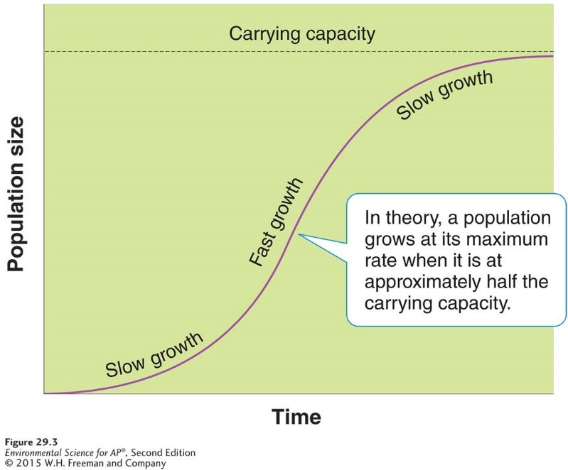
Example: Imagine no restrictions or “seasons” on deer hunting in a public forest. Hunters would have no limitations and could hunt the deer to endangerment. However, if we allow for no hunting, the deer would grow too large and there not be enough food. Intermediate amount of hunting will leave enough deer population to reproduce at a rate that will maintain the population. This solution is MSY.
MSY is very difficult to calculate and we won’t know if it is effective until possibly years later.
Public lands are classified according to their use
International categories of Public Lands
National Parks (400 million ha): Makeup about 2.7% of Earth’s land area; scientific, educational, and recreational, but they can displace indigenous human populations in their creation. EX: Kruger National Park, South Africa
Managed Resource Protected Areas (440 million ha): sustained use of biological, mineral, and recreational resources. EX: Great Smoky Mountains National Park, US
Habitat/Species Management Areas (300 million ha): actively managed to maintain biological communities, for example through provision of fire prevention or predator control. EX: Karelia, Russia.
Strict Nature Reserves and Wilderness Areas (200 million ha): established to protect species and ecosystems. EX: The Chang Tang Reserve, China.
Protected Landscape and Seascape (100 million ha): these areas combine nondestructive use of natural resources with opportunities for tourism and recreation. EX: Batanes Protected Landscape and Seascape, Philippines
National Monument (28 million ha): protect unique sites of special natural or cultural interest. EX: Arc de Triomphe, Paris, France.
Public Lands in the US
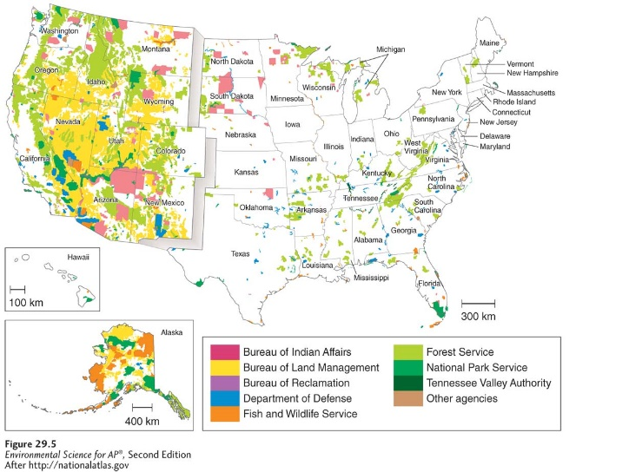
Can be owned by federal (25% of land in the US is federal owned), state, or local govt.
Public lands in the US include rangelands, national forests, national parks, national wildlife refuges, and wilderness areas.
Resource conservation ethic: the belief that people should maximize use of resources, based on the greatest good for everyone
Multiple use lands: A US classification used to designate lands that may be sued to recreation, grazing, timber, harvesting, and mineral extraction.
The probable use of public land determines how it is classified and which federal agency will manage it.
BLM (Bureau of land management) lands: grazing, mining, timber harvesting, and recreation
USFS (United States Forest Service) lands: timber harvesting, grazing, and recreation
NPS (National Park Service) lands: recreation and conservation
FWS (Fisheries and Wildlife Service) lands: wildlife conservation, hunting, and recreation.
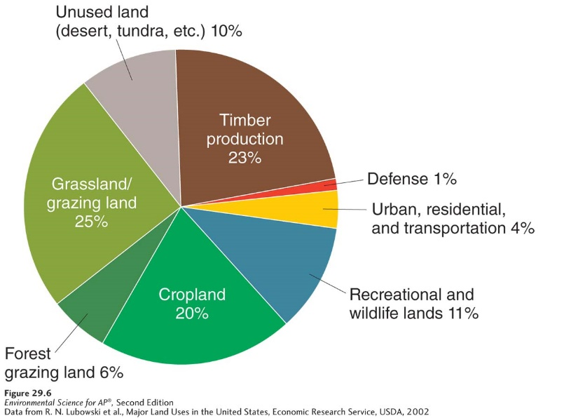
Land Management Practices
Rangeland: a dry open grassland
When humans overuse rangelands, the biodiversity can decrease.
One environmental benefit is that ungulates (hoofed animals) can be raised on lands that are too dry for farming. However, improperly managed livestock can damage stream banks and pollute surface waters. Grazing too many animals can denude the region of vegetation, which leaves the area exposed to wind erosion.
The Taylor Grazing Act of 1934 was passed to halt overgrazing. Its goal was to convert federal rangelands from a common to a permit-based grazing system. The goal of a permit-based system is to limit the number of animals grazing in a particular area and thereby avoid a tragedy of the commons situation. However, it is not very effective currently due to low cost of the permits.
Forest: land dominated by trees and other woody vegetation and sometimes used for commercial logging.
~73% of the forests used for commercial timber operations in the US are privately owned~
Timber harvest practices
- Clear-cutting: a method of harvesting trees that involves removing all of almost all of the trees within an area.
Clear cutting leaves forests open to erosion (which can also deposit the eroded sediment into nearby waters, effecting aquatic life); regrowth after clear-cutting will consist entirely of trees that are the same age; and because there are no large trees for shade, increased sunlight can raise the temperature of nearby rivers and streams.
Clear-cutting also reduces biodiversity because they can no longer use the trees for food and shelter to survive.
The BENEFIT of this type of forestry is less expensive and allows trees and other plants with high sunlight requirements to flourish as regrowth.
- Selective cutting: the method of harvesting trees that involves the removal of single trees or relatively small number of trees from among many in a forest.
Less economical to clear cutting, because the machines have to maneuver around the trees.
Better for the environment because it leaves trees for organisms, but with both programs, roads have to be constructed through the forest for the logging trucks to get in and out.

*bird populations will decrease with clear-cutting, but insect populations can increase due to the amount of rotting wood remaining*
3) Ecologically sustainable forestry: an approach to removing trees from forests in ways that does not unduly affect the viability of other trees.
The approach has a goal of maintaining both plants and animals in as close of a natural state as possible.

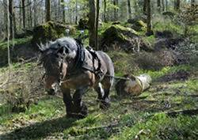
Logging, Deforestation, and Reforestation
~30% of all commercial timber in the world is produced in US and Canada~
Logging often replaces complex forest ecosystems with tree plantations.
Tree plantations: large areas typically planted with a single rapidly growing tree species.
These same age stands can be easily clear-cut for commercial purposes and then replanted. Because of this cycle of planting and harvesting, tree plantations never develop into mature, ecologically diverse forests. With too many of the cycles, the soil can become depleted.

Fire Management
Review from chapter 3: when fires periodically move through an ecosystem, they liberate nutrients tired up in dead biomass. In addition, areas where vegetation is killed by fire provide openings for early-successional species. The USFS spends a lot of time suppressing fires, which leads to large quantities of biomass on the forest floor and can build up until a fire is inevitable.
One method for reducing the accumulation of dead biomass is a prescribed burn.
Prescribed burn: a fire deliberately set under controlled conditions in order to reduce the accumulation of dead biomass on a forest floor.
Prescribed burns help to recycle nutrients back into the ecosystem to enhance future growth of native species.
http://www.fire.ca.gov/communications/downloads/fact_sheets/TheBenefitsofFire.pdf
What is another biome that could benefit from controlled burning?
https://www.fws.gov/midwest/endangered/insects/kbb/savanna.html
National Parks
Reducing the activities of humans inside and outside the park borders is the primary challenge of most national parks.
Air and water pollution from distant sources can reduce biodiversity, recreational value, and economic opportunities.
Although partially designed for aesthetic and cultural pleasure, human activities in national parks can be harmful.
Ex: ATV use are a major cause of air and noise pollution and direct habitat destruction. Parks have now banned or limited the use of ATVs.
Wildlife Refuges and Wilderness Areas
National wildlife refuge: a federal public land managed for the primary purpose of protecting wildlife
National wilderness area: an area set aside with the intent of preserving a large tract of intact ecosystem or a landscape
- Sometimes only a portion of an ecosystem is included in the area.
- Created from other public lands and are managed by the same federal agency prior to their designation as wilderness.

Federal Regulation of Land Use
National Environmental Policy Act (NEPA): a 1969 US federal act that mandates an environmental assessment of all projects involving federal money or federal permits.
Before a project can begin, NEPA requires the project’s developers to file an environmental impact statement
Environmental impact statement: a document outlining the scope and purpose of development project, describing the environmental context, suggesting alternative approaches to the project, and analyzing the environmental impact of each alternative
In some situations, NEPA rules may stipulate that building permits or government funds be withheld until developer submits an environmental mitigation plan.
Environmental mitigation plan: a plan that outlines how a developer will address concerns raised by a project’s impact on the environment.

Residential land use is expanding
Suburb: an area surrounding a metropolitan center, with a comparatively low population density
Exurb: an area similar to a suburb, but unconnected to any central city or densely populated area
~urban is an area with more than 2,500 people~
Rural population accounts for less than 1/5 of the US population
Population shifts have created a new set of environmental problems associated with urban sprawl
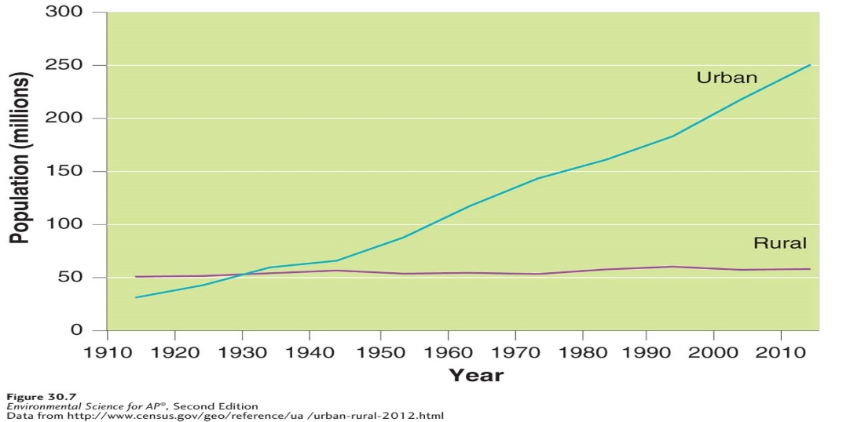\
Urban sprawl: urbanized areas that spread into rural areas, removing clear boundaries between the two
Causes and consequences of Urban Sprawl
Living costs, automobiles and highway construction, urban blight, and government policies
Dependence on automobiles causes suburban residents to drive more than twice as much as people who live in cities. 1950-2000, number of vehicle miles traveled has tripled. Since suburban house lots tend to be larger than the urban counterparts, they use twice as much land per person as urban communities. Urban Sprawl tends to occur at the edge of a city, replacing farmland and increasing the distance between farms and communities.
Land in the suburbs is relatively inexpensive. Tax rates are typically lower in suburbs as well. This is a huge plus to people choosing suburbs over city living.
Single family dwellings are the primary properties in the suburbs, which can typically exclude those of lower incomes. Suburban areas also rely on commuting to and from the city. This is not a viable option for lower-income families since some don’t own reliable vehicles or vehicles at all.
Urban Blight: The degradation of the built and social environments of the city that often accompanies and accelerates migration to the suburbs
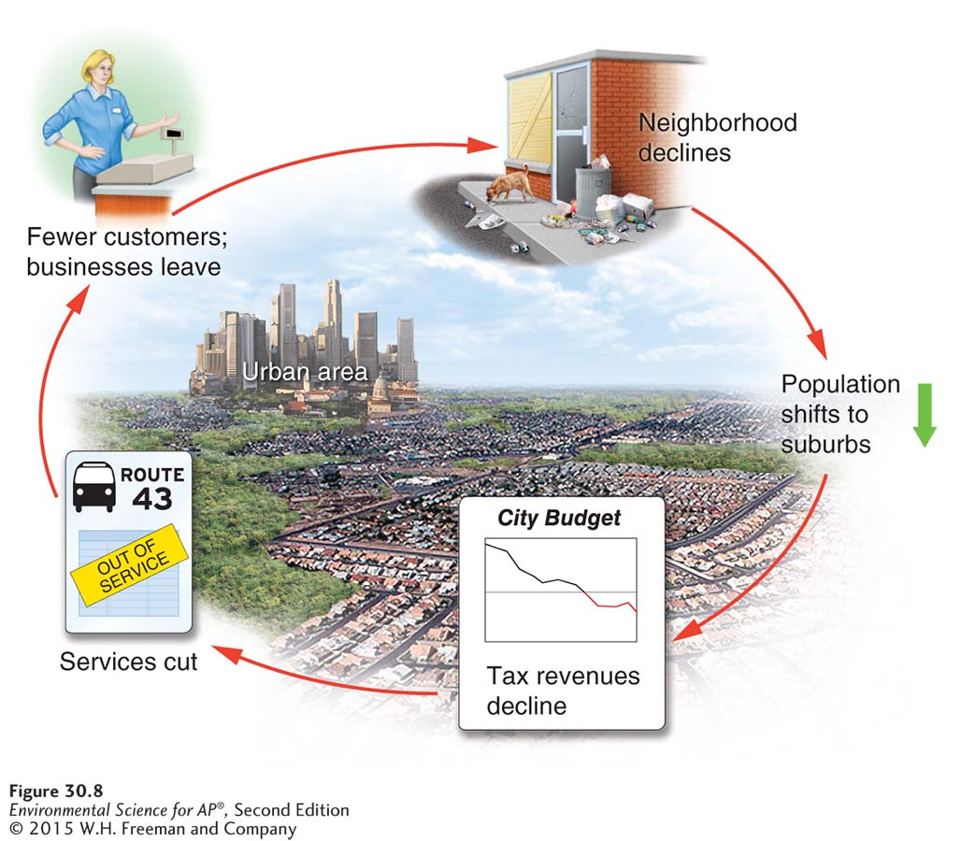
1)Population shifts to suburbs, taking with it revenue from taxes (sales, property, and service)
2) Tax revenue declines, leaving less money for urban services maintenance
3) less money to operate and maintain public services
4) As services decline, crime may increase. Fewer customers are also around, so businesses leave.
5)Neighborhoods decline, people move away

Urban sprawl has been enhanced by government policies
Highway trust fund: a US federal fund that pays for the construction and maintenance of roads and highways
~highways allow people to live farther away from where they work~
Induce demand: the phenomenon in which an increase in the supply of a good causes demand to grow. See below.
Zoning: a planning tool used to separate industry and business from residential neighborhoods
Multi-use zoning: a zoning classification that allows retail and high-density residential development to coexist in the same area.

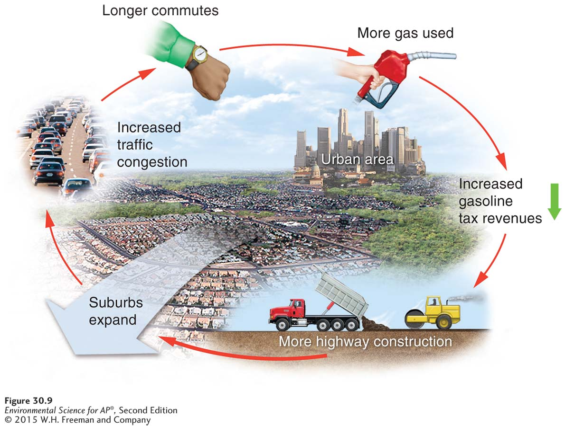

Smart Growth: set of principles for community planning that focuses on strategies to encourage the development of sustainable, healthy communities.
- Create mixed land uses. This allows people to walk or bicycle to various destinations.
- Create a range of housing opportunities and choices: provides housing for all levels of income & allows more people to find jobs where they live, improves schools, and generates strong support for neighborhood transit stops.
- Create walkable neighborhoods: people use cars less and reduce fossil fuel use; communities with more pedestrians tend to see more interaction among neighbors.
- Encourage community and stakeholder collaboration in development decisions: residents and stakeholders work together to determine how their neighborhoods will be structured.
  - Stakeholder: a person or organization with an interest in a particular place or issue
- Take advantage of compact building design: parking garages, ideally, shops and small business would be easily accessible with offices and apartments on top
- Foster distinctive, attractive communities with a strong sense of place: unique neighborhoods, ex: the French Quarter in NOLA.
  - Sense of place: the felling that an area has a distinct and meaningful character
- Preserve open space, farmland, natural beauty, and critical environmental areas: habitats for species, local produce.
- Provide a variety of transportation choices: Transit-oriented development (TOD): a development that attempts to focus dense residential and retail development around stops for public transportation, a component of smart growth. Sidewalks, light rail service.
- Strengthen and direct development toward existing communities:
  - Infill: development that fills in vacant lots within existing communities
  - Urban growth boundaries: a restriction on development outside a designation area
- Make development decisions predictable, fair, and cost-effective.

