Feeding the World
Human Nutritional Needs
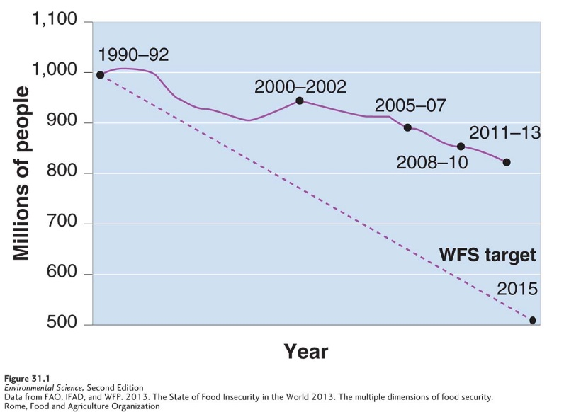
Undernutrition: the condition in which not enough calories are ingested to maintain health.
Global Undernutrition is declining, but not at target

Malnourished: having a diet that lacks the correct balance of protein, carbohydrates, vitamins, and minerals. WHO estimates that about 3 billion people are malnourished.
Food Security: a condition in which people have access to sufficient, safe, and nutritious food that meets their dietary needs for an active and healthy lifestyle.
- Defined by the FAO Food and Agriculture Organization of the UN
- Access refers to the economic, social, and physical availability of food
Food insecurity: a condition in which people do not have adequate access to food.
Famine: the condition in which food insecurity is so extreme that large numbers of deaths occur in a given area over a relatively short period.
- Definition changes within different govt agencies.
- One relief agency defines famine as having more than 5 deaths, per 10,000 people a day due to the lack of food
  - According to this definition, there is an annual mortality rate of 18% during a famine.
The WHO estimates that more than 250,000 children a year become blind due to a vitamin A deficiency.
Anemia: a deficiency of iron
- Estimated 3 billion people in the world are anemic
- Diets and some diseases can cause anemia
Overnutrition: ingestion of too many calories and a lack of balance of foods and nutrients
- WHO estimates that over 1 billion people are overweight
- 300 million of those 1 billion are obese, more than 20% above their ideal weight
- Puts people are risk for heart disease, type 2 diabetes, hypertension, stroke.
- Present in developed AND developing countries with malnourished children.
- Childhood obesity is on the rise
- Partially due to the availability and affordability of over processed foods contains HFCS.
There are over 50,000 edible plant species worldwide, but only three of them (corn, rice, wheat) constitute 60% of human energy intake.
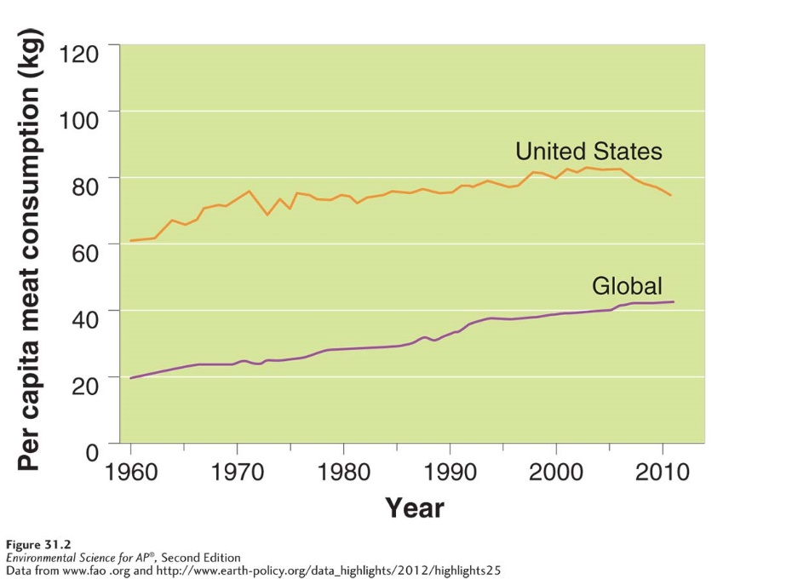
Meat: livestock or poultry consumed as food, 2nd largest component of human diet
Globally (annually), we produce about 300 kg (660 lb.) of grain per person, 43 kg (95 lb.) meat/person, and fish about 21 kg (46 lb.)/ person.
Meat consumption tends to increase with an income increase.
US is 2nd in meat consumption, after Luxemburg.
Recent decline in US, why?

Undernutrition and malnutrition occur primarily because of poverty
Currently, the worlds farmers grow enough grain to feed at least 8 billion people.
If this is the case, then why is malnutrition and undernutrition such a problem?
- Poverty is the number one reason for undernutrition and malnutrition
  - Global experts say that the global food exists, but not everyone has access to it
- Political and economic factors play a role as well.
  - For example, refugee populations that have fled their homes due to war or natural disasters may not have access to food that they grew and stored but had to leave behind
  - The lack of food has led to political unrest because people without means to feed themselves often resort to crime or violence in an attempt to improve their situation
- A large amount of food supply is diverted to feed livestock (40%)
  - Corn and soybean (in US) are grown more for livestock
- Factors affecting grain production:
  - Amount of land under cultivation
  - Global weather and precipitation patterns
  - World prices for grain
  - Productivity of the land the crop is on

Year | U.S per capita meat consumption (kg) | Global per capita meat consumption (kg)
1960 | 60 | 20
1965 | 66 | 22
1970 | 74 | 22.5
1975 | 71 | 23
1980 | 75 | 26
1985 | 76 | 29
1990 | 76 | 32
1995 | 78 | 38
2000 | 80 | 39.5
2005 | 82 | 40
2010 | 76 | 42
2012 | 75 | 42
Graph this data:

Now, find the percentage change in global meat consumption and the percentage change in the US meat consumption
$\frac{(current-original)}{original}$ X 100 = percent change

Modern Large-Scale Farming Methods
Modern industrial farming methods have transformed agriculture:
Industrial agriculture: Agriculture that applies the techniques of mechanization and standardization, also known as agribusiness.
Energy Subsidy: The fossil Fuel energy and human energy input per calorie of food production.
- If we use 5 calories of energy to produce food, and we receive 1 calorie of energy when we eat the food, then the food has an energy subsidy of 5.
  - It takes 20 kg of grain to feed to cattle to produce 1 kg of beef, the energy subsidy is 20 kg
The Green Revolution
A shift in agricultural practices in the twentieth century that included new management techniques, mechanization, fertilization, irrigation, and improved crop varieties, and that resulted in increased food output.
- Began with crop scientists, that developed strains of wheat that were disease resistant and produced higher yields. The upward trend of global crop production is partially due to this development.
- Mechanization:
  - Since the advent of mechanization large farms producing staple crops (beans or corn) have generally been more profitable than small farms. Size matters because of the economics of scale: the observation that average costs of production fall as output increases.
    - A large farm will benefit more from the investment in a $150,00 combine harvester than a small farm would.
  - Mechanization also applies to farms that grow single-crops instead of multiple crops. Multiple different crops requires different machines, meaning more expense.
- Irrigation:
  - Different types of irrigation previously discussed in chapter 9
  - While advanced irrigation has its positives, but there are consequences:
    - Deplete groundwater, draw down aquifers, cause saltwater intrusion into freshwater wells, soil degradation, waterlogging, and salinization.
    - Waterlogging: a form of soil degradation that occurs when soil remains under water for prolonged periods
    - Salinization: a form of soil degradation that occurs when the small amount of salts in irrigation water becomes highly concentrated on the soil surface through evaporation
- Fertilizers:
  - Organic fertilizer: fertilizer composed of organic matter from plants and animals
    - Typically generated on or near the farm where it is used.
      - Collected, composted, spread (very difficult)
      - Many large farms purchase the fertilizer from local chicken or cow farms
      - increase water retention ability of the soil
  - Synthetic fertilizer: fertilizer produced commercially normally with the use of fossil fuels, also known as inorganic fertilizer
    - Come in liquid or solid form.
    - Purchased and transported and are typically easier to spread
    - Typically much more expensive than organic
    - Consequence: require fossil fuel, may lead to runoff and subsequent problems in local waterways
  - The US uses somewhat less fertilizer and consequently experiences less nutrient runoff than other nations with similar agriculture output.
- Monocropping: an agricultural method that utilizes large planting of a single species or variety.
  - Dominant agri. Practice in the US
    - Wheat and cotton, monocrops of 400ha or more
    - Allows large expanses of land to be planted and harvested at the same time.
    - Fertilizer and pesticide treatment can be done at the same time as well
    - Can lead to environmental degradation:
      - Soil erosion
      - Wind erosion to bare soil
      - More vulnerable to pest attack
        - Establish and reproduce quickly
- Pesticides: a substance, either natural or synthetic, that kills or controls organisms that people consider pests
  - In US 227 million kg are applied to crops yearly
    - Accounts for 1/3 of worldwide use
  - Insecticides: a pesticide that targets species of insects and other invertebrates that consume crops
  - Herbicide: a pesticide that targets plant species that compete with crops
  - Broad-spectrum pesticides: a pesticide that kills many different types of pests
  - Selective pesticide: pesticide that targets a narrow range of organisms
  - Environmental problems:
    - Persistent pesticides: a pesticide that remains in the environment for a long time (DDT example)
    - Nonpersistent pesticide: a pesticide that breaks down rapidly, usually within weeks or months (applied more often)
    - Pests may evolve resistance
      - Pesticide resistance: a trait possessed by certain individuals that are exposed to a pesticide and survive
    - Pesticide treadmill: cycle of pesticide development, followed by pest resistance, followed by new pesticide development.
    - They may kill organisms that benefit farmers, i.e. predatory insects that eat pests, pollinators, and plants that fix nitrogen and improve soil fertility
    - Toxic to farmworkers
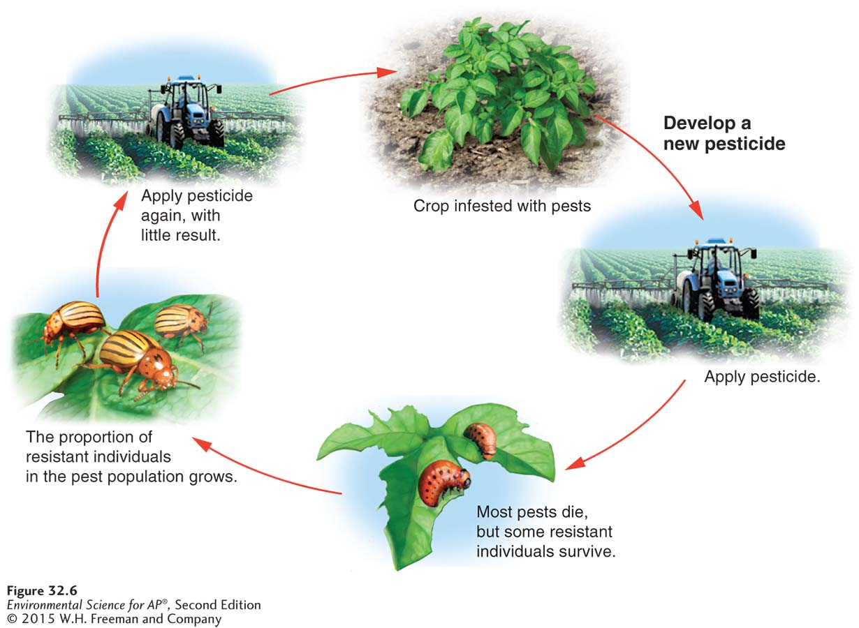

Genetic engineering is revolutionizing agriculture
A GMO is an organism that has been produced by isolating a gene from one organism and transferring it into genetic material of another, often very different, organism.
Benefits:
- Increased crop yield and quantity
Ex: golden rice. Scientists have inserted a gene that synthesizes a precursor to Vitamin A in white rice. Scientists hope the increased vitamin A in the golden rice will decrease the chance of blindness.
- Improved nutritional benefits in some crops
- Reduced use of pesticides
- Higher profits
Concerns:
- Safety for human consumption
- Effects on biodiversity
  - If the GMO crops breed with non-GMO, the genetic sequence will spread and reduce worldwide plant diversity
- Lack of regulation
  - US does not require labeling
  - EU allows very limited GMO
  - France, Germany, and Italy allow none
  - No GMO animals are currently approved for the market… yet.
Modern agribusiness includes farming meat and fish
High-Density Animal Farming
Concentrated animal feeding operation (CAFO): large indoor or outdoor structure designed for maximum output, AKA Feed Lots.
May contain 2,500 hogs or 55,000 turkeys in a single building
By keeping animals confined, farmers limit land use, improve feeding efficiency, and increase fraction of food energy that goes into the production of animal body mass.
Given antibiotics and nutrient supplements to combat adverse effects of such conditions
Antibiotic use contributed to antibiotic resistant strains of micro-organisms that can affect humans
Waste disposal is a serious problem (~2,000 tons of manure annually, which is usually used to fertilize farmland, but is overuse can lead to nutrient runoff problems)
Sometimes waste is disposed of in lagoons, but heavy rainstorms can cause runoff.
Harvesting Fish and Shellfish
Fishery: a commercially harvestable population of fish within a particular ecological region
Tragedy of commons
No country has an incentive to protect fish stocks or to attempt to replenish them because fish in the ocean do not belong to any one nation or individual
Fishery collapse: the decline of a fish population by 90% or more.
Large-scale, high-tech fishing can adversely affect target and nontarget species.
Intensive fishing leads to the loss of juvenile fish of the target species as well as to the loss of noncommercial species that are accidentally caught in nets and lines. This unintentional catching of nontarget species is referred to as bycatch.
Alternatives to Industrial Farming Methods
Shifting agriculture and nomadic grazing
Shifting agriculture: an agriculture method in which land is cleared and used for a few years until the soil is depleted of nutrients
Uses a technique sometimes called “slash-and-burn”, in which existing trees and vegetation are cut down, placed in piles, and burned. The resulting ash are rich in potassium, calcium, and magnesium, which makes the soil more fertile, but these nutrients are quickly depleted. If the deforestation occurs in an area with heavy rainfall, nutrients may be washed away, along with the soil. After a few years, the farmer moves on to another plot of land.
The soil can replenish within a decade, but it is often not give ample time to recover. This causes soil productivity to decrease, leaving land only suitable for animal grazing. The burning of the land also releases CO and CO2.
Desertification: the transformation of arable, productive land to desert or unproductive land due to climate change or destructive land use.
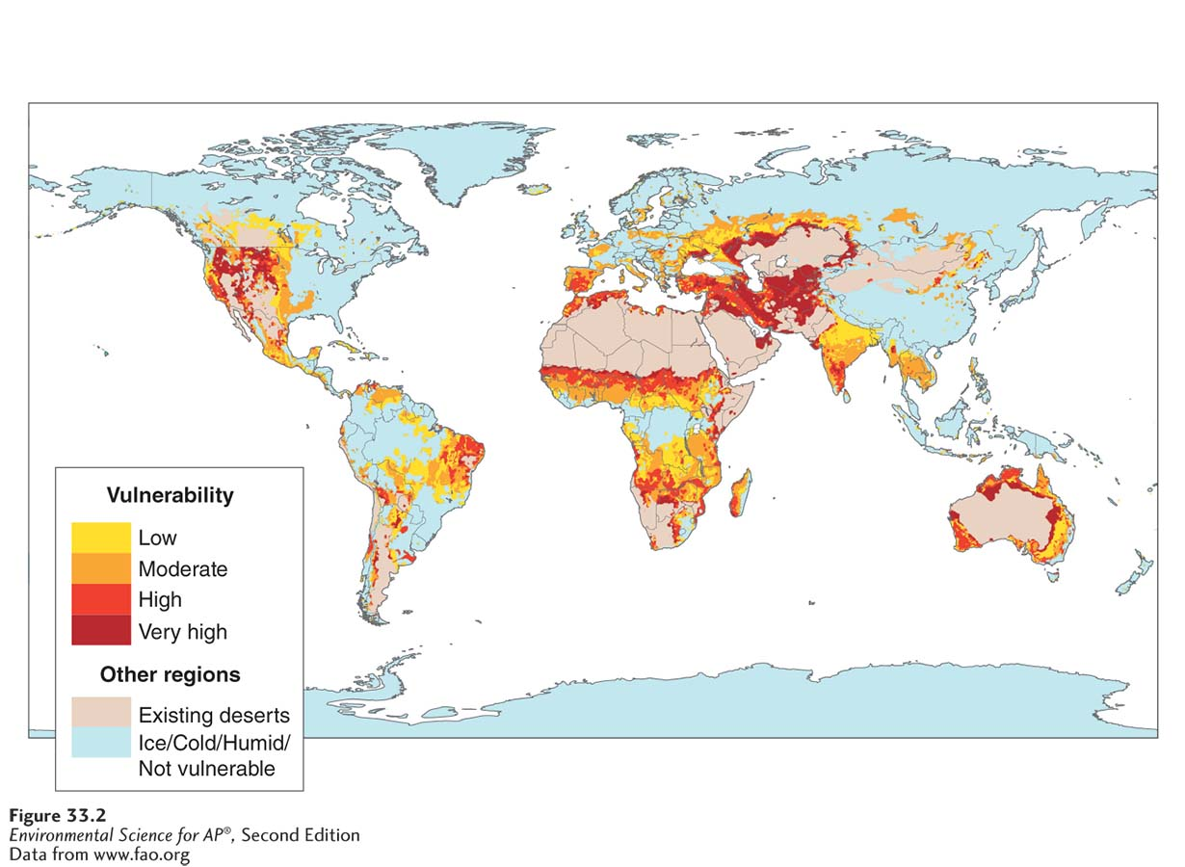

Nomadic grazing: the feeding of herds or animals by moving them to seasonally productive feeding grounds, often over long distances.
If grazing animals move from region to region and do not stay in one place too long, vegetation can usually regenerate.
Sustainable agriculture: agriculture that fulfills the need for food and fiber while enhancing the quality of the soil, minimizing the use of nonrenewable resources, and allowing economic viability for the farmer.
The table below displays the different types of sustainable farming practice

Sustainable farming practice | Definition | Advantage | Disadvantage
Intercropping | An agricultural method in which two or more crop species are planted in the same field and promote synergistic interaction | Can reduce the amount of fertilizer | Requires scientific expertise on plant interactions; can be more labor intensive
Crop rotation | An agricultural technique in which crop species in a field are rotated from season to season | Can reduce the amount of fertilizer required | Requires scientific expertise on plant interactions; can be more expensive
Agroforestry | An agricultural technique in which trees and vegetables are intercropped | Reduces erosion by wind | Land management is more complex; can be more labor intensive and costly
Contour plowing | An agricultural technique in which plowing and harvesting are done parallel to the topographic contours of the land | Conserves soil and helps prevent erosion by water | Land management is more complex; can be more labor intensive and costly
No-till agriculture | An agricultural method in which farmers do not turn the soil between seasons so that topsoil erosion is reduced | Reduces topsoil erosion and reduces emissions of CO2 | Farmers may need to use herbicides before and after planting crops

Perennial plant: a plant that lives for multiple years
Annual: a plant that lives only one season (corn and wheat)

Integrated Pest Management (IPM): an alternative agricultural practice that uses a variety of techniques designed to minimize pesticide inputs
EX: Intercropping, crop rotation, use of pest-resistance crop varieties, and limited use of pesticides

IPM training uses a variety of techniques designed to minimize pesticide inputs. During IPM training, farmers learn how to reduce pesticide use. Farmers spend less money on pesticides and have a higher crop yield. There is less pesticide runoff in local waterways. Nontarget species are not subject to extermination from pesticides intended for pest species.
After IPM training, farmers used less pesticide and their crop yields increased

Organic Agriculture
Production of crops without the use of synthetic pesticides or fertilizers
Basic principles:
- Use ecological principles and work with natural systems rather than dominating those systems
- Keep as much organic matter and as many nutrients in the soil and on the farm as possible
- Avoid the use of synthetic fertilizers and synthetic pesticides
- Maintain the soil by increasing soil mass, biological activity, and beneficial chemical properties
- Reduce the adverse environmental effects of agriculture
Since organic farmers do not use herbicides, they are less likely than conventional farmers to be able to use no-till methods successfully. And alternative pest control methods are always environmentally friendly.
EX: In order to keep crops such as carrots free of weeds, organic farmers may treat the soil with a flame fueled by propane before planting. This requires the use of fossil fuels.
Alternative techniques for farming animals and fish are becoming more popular
Not all meat come from CAFO’s. Free-range chicken and beef are increasing in popularity in the US. Some people find it more ethically acceptable to eat chicken or beef that has wandered free, rather than living in a confined space. Free-range animals are more sustainable. Because they are in the open air, they are less likely to pass disease onto each other, therefore limiting or eliminating the need for antibiotics and other medication. The animals graze the land, so there is less supplemental feeding, so less fossil fuels go into the feeding of free-range meat. Lastly, manure and urine are naturally deposited and utilized by decomposers in the soil.
HOWEVER, free-range operations require more land usage than CAFO’s. Due to this, the cost of meat produced is usually higher.
More sustainable fishing:
In the interest of creating and supporting sustainable fisheries, many countries around the world have developed fishery management plans, often in cooperation with one another.
Why is international cooperation important?
BECAUSEEEE FISH MIGRATE ACROSS NATIONAL BORDERS
EX: The northwestern Atlantic fisheries comprise several continental shelf ecosystems that stretch from the northeastern US to southeastern Canada. Historically, these fisheries were the most productive in the world, but overfishing by international fleets of factory ships led to depletion of fish stock. The fisheries were forced to close and US and Canada imposed a moratorium on bottom fishing in the area.
As a result, the US Congress passed the Sustainable Fisheries Act in 1996. This act shifted the primary focus of fisheries from economic sustainability to an approach that increasingly stressed conservation and the sustainability of species. The act also calls for the protections of marine habitat.
In 1973, fishery managers introduced a system of individual transferable quotas (ITQ’s): a fishery management program in which individual fisheries are given a total allowable catch of fish in a season that they can either catch or sell.
EX: Before the start of every salmon season, fishery managers establish an allowable catch and distribute and sell quotas to individual fishers or fishing companies. If fishers cannot catch enough salmon to remain economically viable, they can sell all or part of their quota to another fisher. The graph shows how ITQ’s have improved salmon populations.
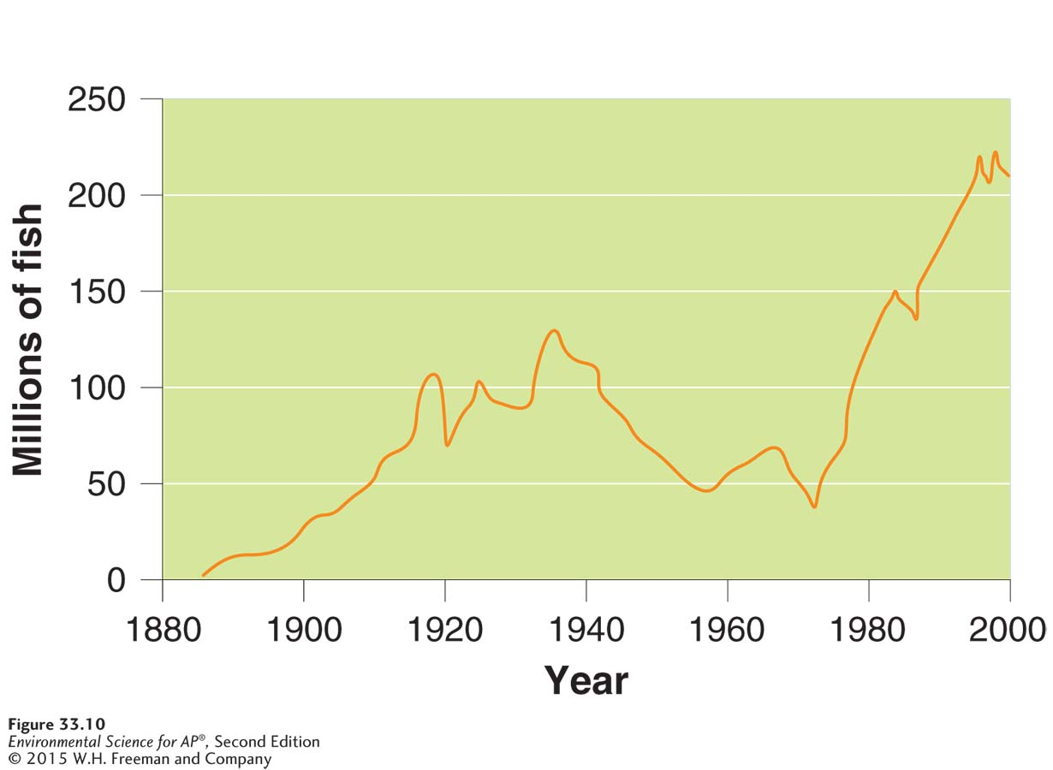

Aquaculture: farming aquatic organisms such as fish, shellfish, and seaweeds.
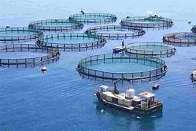

Clean water is pumped in at one end of a pond or marine enclosure and wastewater containing feces, uneaten food, and antibiotics are pump back into the river or ocean at the other end. The wastewater may contain bacteria, viruses, and pest that thrive in the high-density environment of aquaculture and can infest wild fish outside of the facility. However, aquaculture can provide much needed protein for the 1 billion malnourished people of the world and boost economies of developing countries.

