Conservation of Biodiversity
The Sixth Mass Extinction
Why is genetic diversity important?
High genetic diversity ensure that a wider range of genotypes is present, which reduces the probability that an offspring will receive that same harmful mutation from both parents. High genetic diversity also improves the probability of surviving the future change in the environment.
We are currently experiencing global declines in the genetic diversity of wild species.
- Can be natural or human caused
- EX: Cheetah’s have a low diversity (due to bottleneck from ~10,000 years ago)
- EX: hunting decreases the number of animals, which can lead to inbreeding.
We are also experiencing global declines in the genetic diversity of domestic species
- Over thousands of years, humans have selected for numerous breeds of domesticated animals to thrive in local climatic conditions and to resist diseases common in their local environments. Modern breeding, which focuses on productivity, has caused the decline or extinction of many of these animal breeds.
Species Diversity has declined ALL AROUND THE WORLD
Major extinction events are categorized as a loss of at least 75% of all species within a period of 2 million years. Scientists estimate that as a result of these multiple mass extinctions and many minor extinctions, nearly 99% of the 4 billion species have gone extinct.
Threatened species (IUCN): according to the International Union for Conservation of Nature (IUCN), species that have a high risk of extinction in the future.
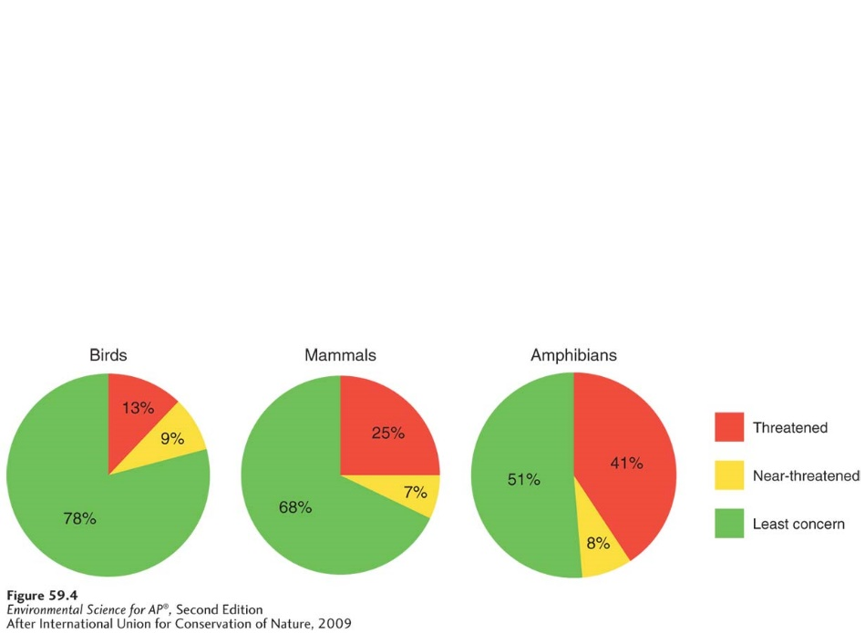
Near-threatened species: species that are very likely to become threatened in the future
Least concern species: species that are widespread and abundant
Of the 10 million species (bacteria whales) on Earth, only about 50,000 of them have been assessed to determine their threat-level.
New species are constantly being discovered, so it makes it near impossible to have data on every single one
Rising sea levels and reduced habitats are partially to blame for a decline in numbers.
Since 1500, 10,000 bird species have existed. 130 are now extinct.
Today, 22% are threatened or near-threatened.
In the US, 800 species live here and 1/3 of them are declining in population.
With mammals, since 1500, 77 species are extinct out of the original 5,500.
Among the 4,600 species for which we have data, 25% are threatened and 32% are either threatened or near-threatened.
Amphibians are experiencing the greatest global decline.
6,300 species, now 34 are extinct.
4,700 that we have data on now, 49% are threatened or near-threatened.
Ecosystem values and the global declines in ecosystem function
Intrinsic value: value independent of any benefit to humans
Instrumental value: worth as an instrument or a tool that can be used to accomplish a goal.
When considering instrumental value, there are 5 categories: provisions, regulating services, support systems, resilience, and cultural services.
Provision: a good that humans can use directly.
Examples: lumber, food crops, medicinal plants, natural rubber, and furs.
Regulating Services: Natural ecosystems help to regulate environmental condition. (Think Carbon – human contribute about 8 gigatons a year, but only 4 gigatons remain there)
Support Systems: Natural ecosystems provide numerous support service that would be VERY expensive for humans to generate.
Example: INSECT POLLINATION!
Natural insect pollination contributes 3.1 billion $$ to the US food production.
What is another example of another ecosystem support system?
Natural predators providing pest control!
Resilience: Several different species may perform similar functions in an ecosystem, but their susceptibility to disturbance will vary.
Cultural Services: natural areas provide aesthetic satisfaction and intellectual gain.
Is it possible to place monetary value on ecosystem services?
Most economists believe so, and they are beginning to incorporate these costs into their calculations of the economic costs and benefits of human activities. Assigning a dollar value to some categories is easier than others.
Causes of Declining Biodiversity
Habitat loss is the major cause of declining species diversity
Many species thrive in a particular habitat within a narrow range of abiotic and biotic conditions. Species requiring such specialized habitats are particularly prone to population declines. As their habitat decreases, species are limited to a smaller geographic area with resources that can only support a small population.
H - habitat loss
I - Invasive species
P - Pollution
C - Climate Change
O - Overharvesting
Exotic species are moving around the world
Native species: species that live in their historical range, typically where they have lived for thousands or millions of years
Exotic species: a species living outside of its historical range; also known as alien species
They are moved on purpose or on accident (rats stowing away on ships).
Invasive species: a species that spreads rapidly across large areas
https://dcmp.org/media/9146-invasion-of-the-earthworms
This rapid spreading occurs because in the new habitat, there is a lack of natural predators of the new species.
Example: Zebra Mussels are native to the Black Sea and the Caspian Sea. Cargo ships would pump water into the holding tanks to ensure it would remain stable. Once the ships arrived in the Great Lakes, they would empty the water since it was no longer needed. When they initially took in the water, they also collected aquatic species. The Great Lakes provided a great ecosystem for the mussels and they thrive there.
Positively, the mussels feed by filtering the water (remove algae and other contaminants).
Adversely, the zebra mussels physically crowd out native species and they consume so much algae that it doesn’t leave much for the other algae-eaters. They can also achieve such high densities that they can clog intake pipes and impede the flow of water for the communities.
What is another invasive species?

How can we prevent the introduction of invasive species?

Not taking seeds or plants from one area to another, inspecting good as you travel from country to country, not transporting water, animals, or plants from one body of water to another, and only purchasing pets that you know are native.
Overharvesting causes declines in populations and species
- the most direct human influence
- overharvesting is removing the species quicker than it can be replaced.
Example: The dodo bird. It had no innate fear of humans, so when sailors stopped at the Mauritius island in the Indian Ocean, they hunted them to the point of extinction within 80 years. The sailors also brought rats on their ships that ate the birds’ eggs. Remember: the dodo bird was flightless so they could not evade the humans.
Laws pertaining to wildlife trade:
Lacey Act & CITES
CITES: Convention of International Trade in Endangered Species of Wild Fauna and Flora.

 | Lacey Act | CITES
Description | One of the earliest laws in the US to control wildlife | A UN agreement among 175 countries throughout the world.
Year Passed | 1900 | 1973
Purpose | The act originally prohibited the transport of illegally harvested game animals, primarily birds and mammals, across state lines. Subsequent amendments prohibited interstate shipping of all illegally harvested plants and animals | The convention helps control international trade of threatened plants and animals. It also maintains the Red List, a list of threatened species worldwide.

-We’ve already touched on how pollution can be harmful to species-
Toxic contaminants threaten biodiversity.
Pollution sources that release nutrients that cause algal blooms and dead zones threaten biodiversity
Climate Change Impact: The change in temperature will alter the change of habitat.

The Conservation of Biodiversity
Marine Mammal Protection Act: a 1972 U.S. Act to protect declining populations of marine mammals.
Endangered Species: a species that is in danger of extinction within the foreseeable future throughout all of a significant portion of its range.
The Endangered Species Act: 1973 law that is designed to protect species from extinction. Authorizes the US Fish and Wildlife Service to determine which species can be listed as threatened species or endangered species and prohibits the harming of such species.
Convention on Biological Diversity: An international treaty to help protect biodiversity.
Theory of Island Biogeography: looks at how the size of islands and the distance between islands and the mainland affect the number of species that are present on different islands.
Metapopulations: collection of a smaller populations connected by occasional dispersal of individuals along habitat corridors.
Edge Habitat: occurs where two different communities come together, typically forming an abrupt transition, (grassy field meets a forest).
It is hard to protect small habitats because of the increased proportion of edge habitats and the need for corridors between some protected species.
Biosphere reserve: protected area consisting of zones that vary in the amount of permissible human impact. 3 zones. Developed by UNESCO. (United Nations Educational, Scientific, and Cultural Organization)
- Central core is an area that received minimal human impact and is the best location to preserve biodiversity.
- Buffer zone encircles the core area. Most amount of human activity are permitted (tourism, enviro education, and scientific research facilities)
- Transition area is the farthest out. Contains sustainable logging, sustainable agriculture, and residences for local {human} population.
By the way, the US has a different definition for a threatened species than the IUCN:
“any species that is likely to become an endangered species within the foreseeable future throughout all or a significant portion of its range”

