Chapter 6: Population and Community Ecology
The Abundance and Distribution of Populations
Population: The individuals that belong to the same species and live in a given area at a particular time
Community: All of the populations of organisms within a given area.
5 levels of complexity:
- The simplest = individual (survival and reproduction)
- The second level = population (population dynamics; evolution occurs here)
- The third level = community (species interaction)
- The fourth level = ecosystem (flow energy and matter)
- The fifth level = biosphere (global processes)
Remember, the boundaries of a population are rarely clear & are arbitrarily set by scientists.
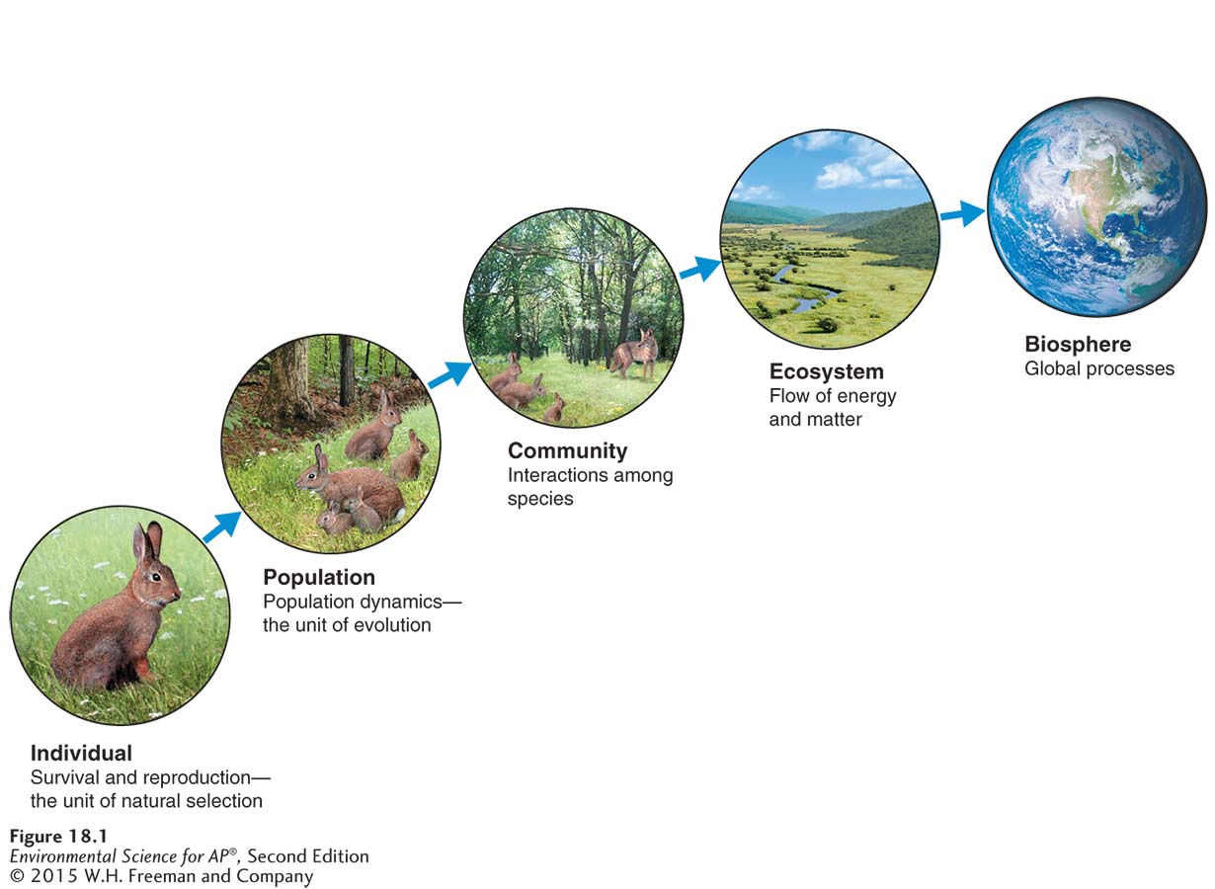

Populations are dynamic and constantly changing. The study of factors that cause populations to increase or decrease is the science of population ecology.
- Knowing the factors that affect a species’ population allows us to implement procedures to improve survival and reproduction.
  - Adversely, knowing these factors can also help us control the population also
To know how populations change we must study their characteristics:
- Population size (N): the total number of individuals within a defined area at a given time.
- Population density: The number of individuals per unit area at a given time.
Knowing the density, in conjunction with the size, will allow scientists to estimate whether a species is rare or abundant.
Density is useful when setting hunting or fishing limits on a species.
- Population Distribution: A description of how individuals are distributed with respect to one another.
Populations in nature distribute themselves in 3 ways:
- Random distribution – no apparent pattern (tree species)
- Uniform distribution – all individuals maintain a similar distance from each other (terrestrial nesting birds)
- Clumped distribution – clusters (schools of fish, flocking birds, etc.)

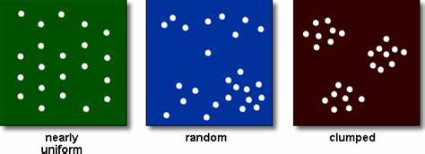
- Population Sex Ratio: The ratio of males to females in a population.
- Helps scientist estimate the number of offspring a population will produce in the next generation
- Population Age Structure: A description of how many individuals fit into particular age categories in a population.
  - Helps predict how rapidly a population can grow.
Population size is affected by density-dependent and density-independent factors
Limiting resource: a resource that a population cannot live without and that occurs in quantities lower than the population would require to increase in size
Density-dependent factor: a factor that influences an individual’s probability of survival and reproduction in a manner that depends on the size of the population.
- Example: since a small population requires less total food, food scarcity will have little effect on the survival and reproduction of individuals in small population, but would have large negative impact on a large population.
Carrying capacity (K): The limit of how many individuals in a population the environment can sustain.
Density-independent factor: a factor that has the same effect on an individual’s probability of survival and the amount of reproduction at any population size.
- Example: A tornado can uproot and kill a large number of trees in an area. However, given a tree’s probability of being killed does not depend on whether it resides in a forest with a high or low density of other trees.
- Hurricanes, floods, fires, volcanic eruptions.
- An individual’s likelihood of mortality increases during such an event regardless of population size.
Population Growth Models
Population growth models: mathematical equations that can be used to predict population size at any moment in time.
Population growth rate: the number of offspring an individual can produce in a given time period, minus the deaths of the individual or its offspring during the same period.
Intrinsic growth rate (r): The maximum potential for growth of a population under ideal conditions with unlimited resources.
If we know the intrinsic growth rate of a population (r), and the number of reproducing individuals that are currently in the population (N₀), we can estimate the populations future size (N_{t}) after some period of time has passed (t). We do this with the exponential growth model:
N_{t} = N₀e^{rt}
e = e^{x} key on calculator or 2.72.
t = time
When graphed, it should produce a j-shaped curve

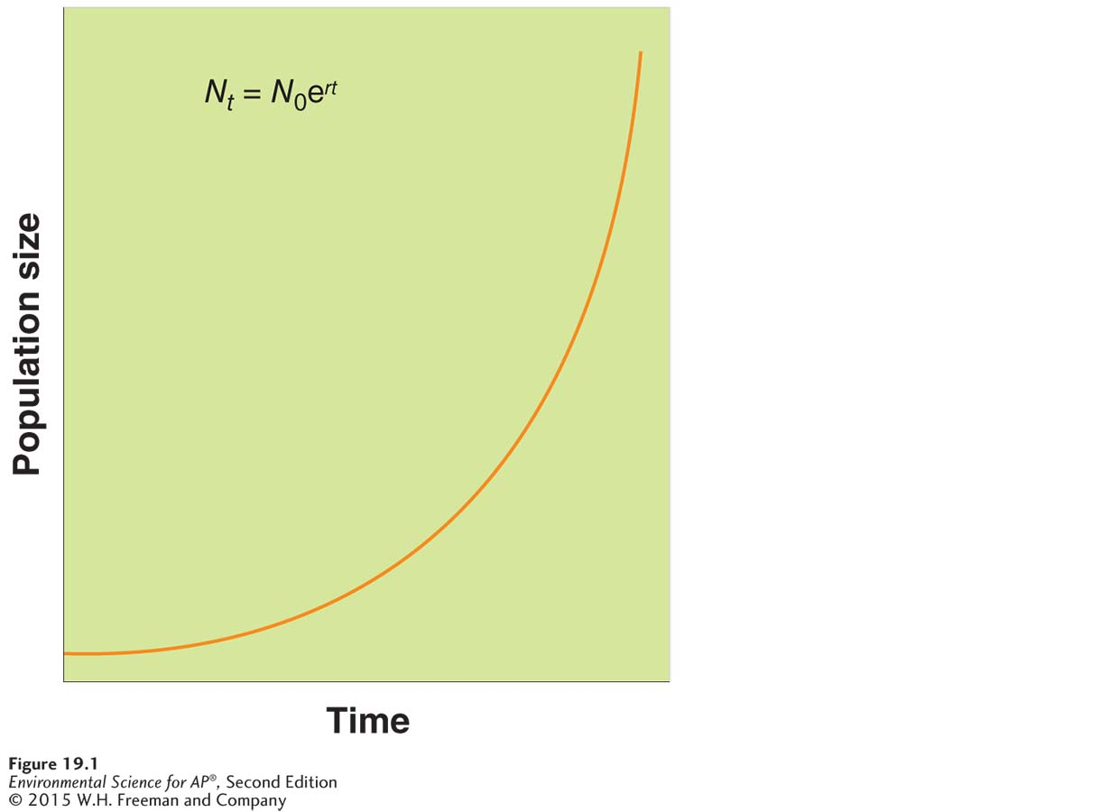

Let’s work an example.
Let’s say you put $1,000 in a bank account at an annual interest rate of 5%. After 1 year the balance is:

What’s the balance in the 10th year?

Since the exponential growth model describes a continuously increasing populations that grows at a fixed rate, populations do not experience exponential growth indefinitely. For this reason, scientists developed the logistic growth model (a growth model that describes a population whose growth is initially exponential but slows as the population approaches the carrying capacity of the environment(K)). Will produce an s-shaped curve.

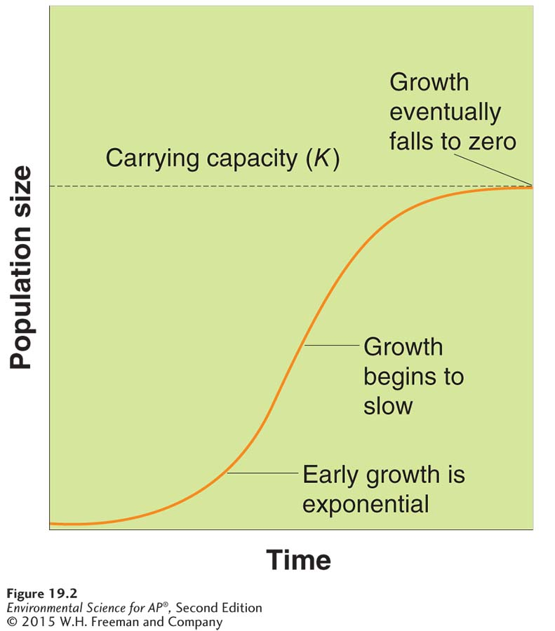
Problem? Some mammals mate during fall or winter and the number of offspring that develop depends on the amount of food available. HOWEVER, when spring rolls around there may not be enough food by then. This causes an overshoot (when a population becomes larger than the environment’s carrying capacity).
This overshoot causes a rapid decline in a population due to death AKA die-off.

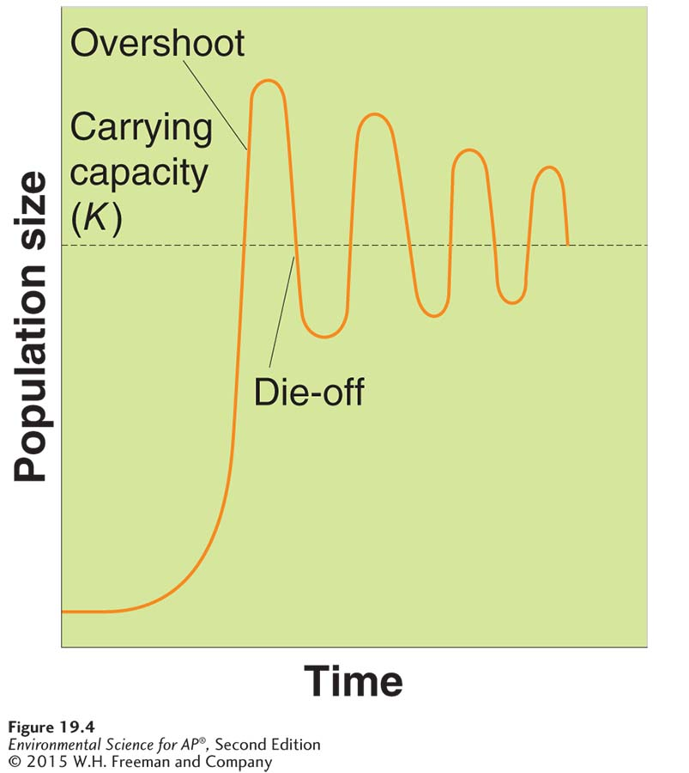

Some populations experience recurring cycles of overshoots and die-offs.
Predation plays a role in limiting population growth.
The lynx population peaks 1-2 years after the hare population peaks. As the hare population increases, it provides more prey for the lynx, so the lynx population increases. As the hare population reaches its peak, the food becomes scarce and the hare population dies off. The decline in hares causes a decline in lynx’s. Since the low lynx numbers reduce predation, the hare population increases again.
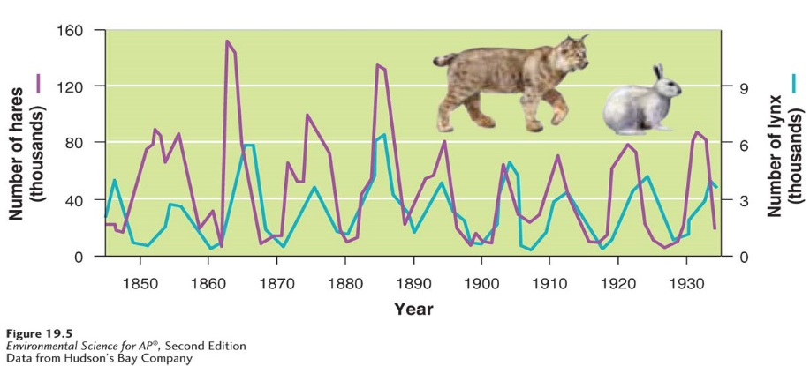
Species have different reproductive strategies and distinct survivorship curves
K-selected species: A species with a low intrinsic growth rate that causes the population to increase slowly until it reaches carrying capacity.
- Elephants and most birds
r-selected species: a species that has a high intrinsic growth rate, which often leads to population overshoots and die-offs.
- House mouse
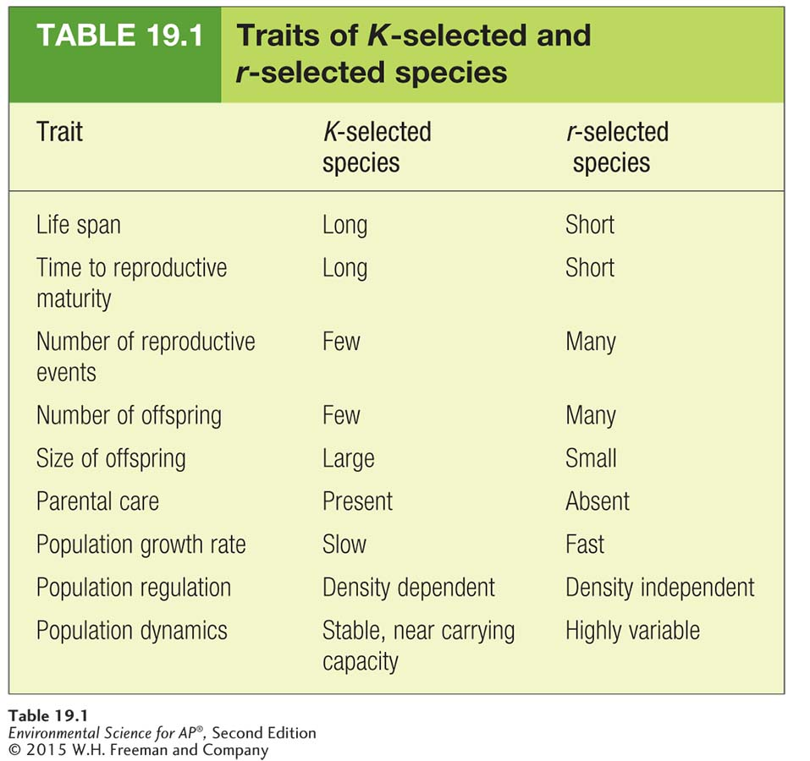

In addition to reproductive strategies, species have different patterns of survival.
They are plotted with survivorship curves (graphs that represent the distinct patterns of species survival as a function of age).
- Type I survivorship curve: a pattern of survival over time in which there is a high survival throughout most of the life span, but then individuals start to die in large numbers as they approach old age. (elephants, whales, humans)
- Type II survivorship curve: a pattern of survival over time in which there is a relatively constant decline in survivorship throughout most of the life span. (corals and squirrels)
- Type III survivorship curve: a pattern of survival over time in which there is low survivorship early in life with few individuals reaching adulthood. (mosquitos and dandelions)
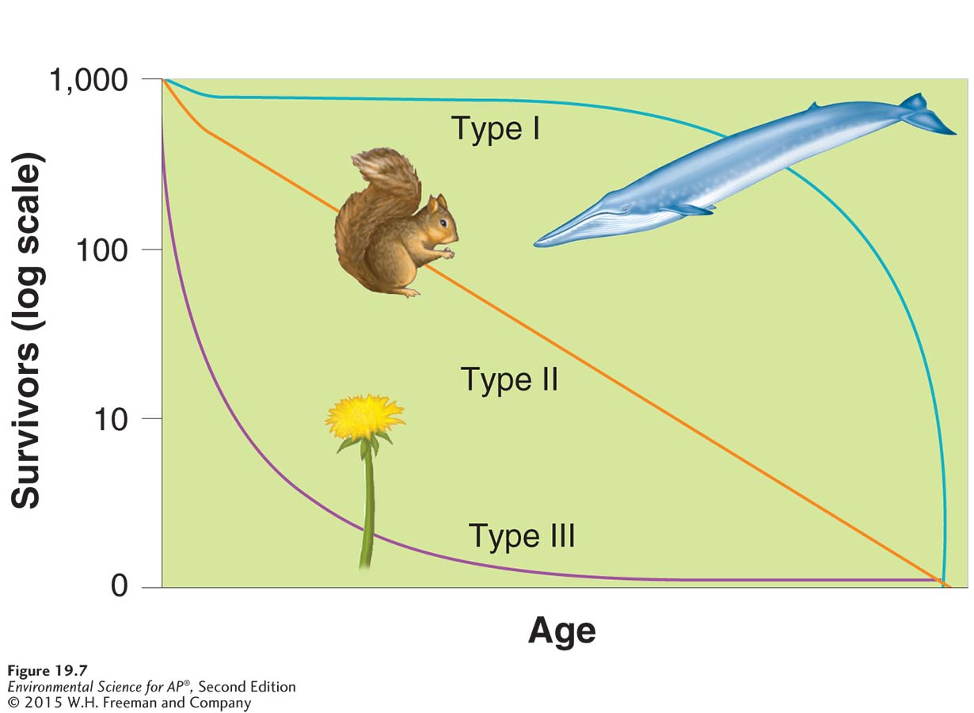

Interconnected populations form metapopulations
Corridors: strips of natural habitat that connect populations
Metapopulation: a group of spatially distinct populations that are connected by occasional movements of individuals between them.
Inbreeding depression: when individuals with similar genotypes-typically relatives- breed with each other and produce offspring that have an impaired ability to survive and reproduce.
A metapopulation is more likely to persist than a small population.
Why?
Individuals can move between subpopulation that make up a metapopulations, which introduces new genetic material, thus increasing diversity and fitness. Since metapopulations consist of numerous, isolated populations, disease is less likely to destroy an entire population, unlike in a small population where it could destroy all of them. Single, isolated populations are more vulnerable to extinction from catastrophic events (fire/frigid winter)

Community Ecology
Community ecology is the study of interactions between species.
Symbiotic relationship: the relationship between two species that live in close association with each other.
Competition: The struggle of individuals to obtain a shared limiting resource.
Competitive exclusion principle: the principle stating that two species competing for the same limiting resource cannot coexist
Resource partitioning: when two species divide a resource based on difference in their behavior or morphology.

- Temporal resource partitioning: different species use a resource at different times to alleviate competition
  - Elephants and okapi using the same watering hole, but at different times
- Spatial resource partitioning: different species use the same resource by using different parts or areas.
  - Species of fish feeding at different depths of the lake.
- Morphological resource partitioning: two competing species evolve different morphologies that enable them to use the same resource in different ways.
  - Two different species of weasels have different skull and tooth sizes so they eat different sized prey
Predation: an interaction in which an animal typically kills and consumes another animal.
- Parasitoid: specialized type of predator that lays eggs inside other organisms (the host)
To avoid predation, many organisms have developed defense mechanisms.
  - Chemical: emit chemicals that are toxic or distasteful to their predators. (walkingstick insect that can spray chemicals)
  - Morphological: developed physical features (spines, camouflage) to protect themselves from predators. (leopard spotted coat)
  - Behavioral: developed behaviors that attract less attention, movement and hiding. (opossum playing dead)
  - Mimicry: species that do not have their own chemical defenses, so they mimic other prey species that do. (Nontoxic frog that has the same appearance as the poison dart frog)
Parasitism: an interaction in which an organism lives on or in another organism.
Pathogen: a parasite that causes disease in its host.

 | Definition | Example | similarity
predator | Kill prey and consume most of what they kill | African lions eat gazelles | In both relationships, one organism benefits and another is harmed. One organism uses the other as its source of energy.
Parasite | Live in or on the organisms but only consume a fraction of their host; rarely kills host. | Tapeworms live in the intestines of animals

Herbivory: an interaction in which an animal consumes a producer.
Interaction | Effect Species 1 | Effect Species 2 | Definition | Example
Competition | - | - | The struggle between 2 individuals to obtain limiting resource | 2 plants competing for sunlight
Predation | + | - | An interaction in which one animal typically kills and consumes another animal | Great horned owls eat small rodents
Parasitism | + | - | An interaction in which one organism lives in or on another organism | A tapeworm lives in the intestine of an animal
Mutualism | + | + | The interaction of 2 species that ^ the chances of survival and repro. for both species. | Plants and pollinators
Commensalism | + | 0 | 1 species benefits and the other species is neither harmed not helped. | Fish using coral reef to hide from predators

Keystone Species
A species that plays a far more important role in its community than its relative abundance might suggest.
Can shape and maintain habitats for other species, can limit dominant competitive species, can have a low abundance, rarely a primary producer.
- Predator-mediated competition: by reducing the abundance of superior competitor species, predator-mediated competition is often essential to the survival of many other populations within a community.
- Mutualistic interactions: Plant and pollinator example. Since plants are a foundation of the food chain, pollinators must provide this ecosystem service or the other populations will collapse.
- Ecosystem engineer: a keystone species that creates or maintain habitat for other species.

Community Succession
Ecological succession: the predictable replacement of one group of species by another group of species over time.
Primary succession: ecological succession occurring on surfaces that are initially devoid of soil. Takes 100’s of years. Volcanic eruptions and glacial retreat can create a new island that can lead to this.
Process: Rocks are colonized by algae or moss. As they grow, they excrete acids that allow them to take up nutrients directly from the rocks. The chemical alteration of the rock allows it to be more susceptible to erosion. When the organisms die, they become the organic matter that mixes with the minerals in eroded from the rock to create new soil. With time, soil develops and becomes a hospitable environment for plants with deep root systems. Mid-successional plants (grasses, wildflowers) are easily dispersed to this area. They are able to survive in nutrient-poor soil. The lives and deaths of these mid-successional plants allow the soil quality to improve by ^ its ability to retain nutrients and water. As a result, new species colonize the area and outcompete the mid-successional species. The type of community that develops is determined by the temperature and rainfall of the region.

Secondary succession: the succession of plant life that occurs in areas that have been disturbed but have not lost their soil. Occurs over a decade or so. Forest fire or agricultural activity might lead to 2ndary succession.
Process: begins with the rapid succession of wind-borne seeds (grasses and wildflowers), which are eventually replaced by better competitors for sunlight, water, and soil nutrients. Trees eventually replace grasses and flowers (if enough rainfall). Trees that colonize the area are typically “easy” trees.
Pioneer species: a species that can colonize new areas rapidly and grow well in full sunshine.
Aquatic Succession may occur along the coastline. If a storm turns over a rock it can be colonized by algae and then by barnacles and mussels. In a freshwater lake, erosion can fill the lake basin with sediment. Aquatic plants can thrive and fill the basin with organic matter over time. As the basin fills, it can then develop into a terrestrial habitat.
The species richness of a community is influenced by:
Latitude: as we move from the poles toward the equator, species richness increases.
Time: The longer a habitat exists, the more colonization, speciation, and extinction can occur. If the rate of colonization and the rate of speciation exceed the rate of extinction, then a habitat present for more time will have more species.
Habitat Size: The larges the habitat, the more species, niches, and potential dispersion exists.
Distance from other communities: If a new island is closer to a colonized land mass, then it will have a greater number of species than an island of the same size that is farther away.
Theory of Island Biogeography: a theory that demonstrates the dual importance of habitat size and distance in determining species richness.
Species richness increases as the size of the habitat increases
How can that theory be applied to conservation efforts?
Larger areas = more diversity

