APES
Air Pollution

Most of the atmosphere (75% by mass) is located in the troposphere. Although relatively thin it is sometimes referred to as the weather breeder.

Just above it is the stratosphere; the source of “good” ozone which screens us from 95% of the sun’s harmful UV radiation.

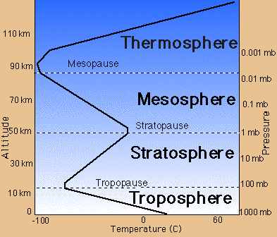

The atmosphere is about 78% Nitrogen (N₂) and 21 % oxygen (O₂). The rest consists of several trace gases: water vapor, argon, carbon dioxide, methane, ozone, nitrous oxide.

There is now a large body of evidence suggesting human activity is responsible for an increase in unwanted ozone in the troposphere and its decrease in the stratosphere.

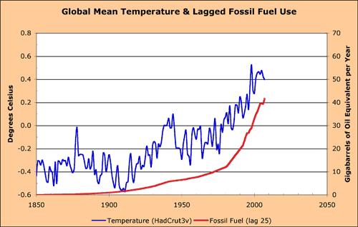

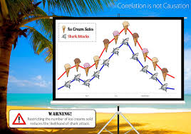

THE CARBON EQUATIONS:
Burning Coal (Solid): C + O₂ --- CO₂

Gasoline (Liquid): 2C₈H₁₈ + 25 O₂ -- 16CO₂ + 18 H₂O

Natural Gas: CH₄ + 2O₂ -- CO₂ + 2H₂O
http://www.youtube.com/watch?v=FM0hczFNDZI arctic methane burning

Air Pollution Problems

Air pollution is the presence of chemicals in the atmosphere which cause harm or alter climate. Air pollution has 2 causes (sources): natural (volcanic dust, forest fires, lightning, plants) and human origin (anthropogenic- on-road vehicles, power plants, industrial processes, waste disposal.).

Pollutants emitted directly into the troposphere are called Primary Pollutants. When these react with other pollutants or gases in the atmosphere they may form secondary pollutants.

Although most air pollution is formed in urban areas, wind can spread long-lived pollutants into rural areas.
~global system~

(Major pollutants: Sulfur Oxides, Nitrogen Oxides, Carbon Monoxide, particulates, and Ozone)
(SOx, NOx, & CO2)
*SO2 & NOx are primary that turn into secondary*
Sources, p. 525

What is a particulate? Solid or liquids suspended in the air.
Where are they from? Combustion of wood, animal manure, and other biofuels, coal, oil, and gasoline. It can also come from: road dust, volcanoes, rock-crushing, forest fires, and dust storms.
Why are they worrisome? Particles below 10 micrometers (PM10) cannot be filtered through the nose/throat and can be deposited in the respiratory tract. PM2.5 are even smaller and deposit deeper and are usually more toxic.

Many developed countries have government-mandated standards for maximum levels of several categories of air pollution. pg. 525, 526: figure 46.6

Photochemical and Industrial Smog

Industrial smog is caused by the burning of coal that has a high sulfur content. It is not much of a problem today in most industrial societies because of pollution control. Most of the cities with the world’s worst air pollution are in China (10 out of 15).
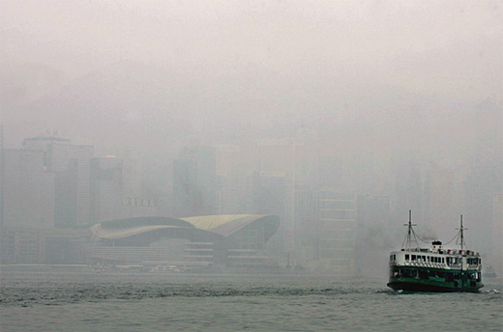

Any chemical reaction activated by light is called a photochemical reaction. Photochemical smog is a combination of VOC’s (volatile organic compounds) and nitrogen oxides that are activated by sunlight. Ozone (2ndary pollutant) also contributes.

VOC evaporate at typical atmospheric temps.
Ex: gasoline, lighter-fluid, dry-cleaner fluid, perfumes, oil paint.
Why are they bad? Their role in the formation of photochemical oxidants (ozone)
VOC: p. 523
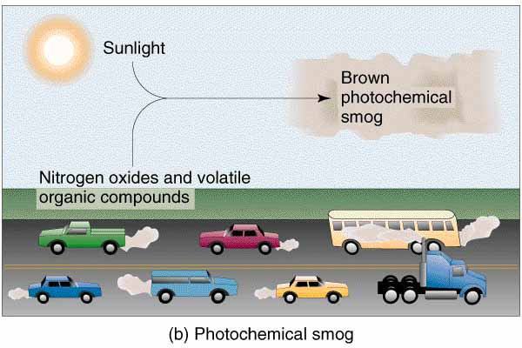
Nitrogen Equations
N₂ + O₂ + Energy ---- 2NO
2NO + O₂ --- 2NO₂

Sunlight
NO₂ ----------NO + O (photochemical smog)
O+ O₂ ----- O_{3 (Ozone: Troposphere = Bad)}

Several of the chemicals in photochemical smog are oxidants which irritate the respiratory system and damage vegetation.

Warmer weather and increased automobile traffic can cause increases in levels of photochemical smog.

Industrial (Sulfurous) smog is the result of the burning of coal and oil. It consists of several sulfur compounds, carbon dioxide and carbon monoxide and particulate matter (soot).
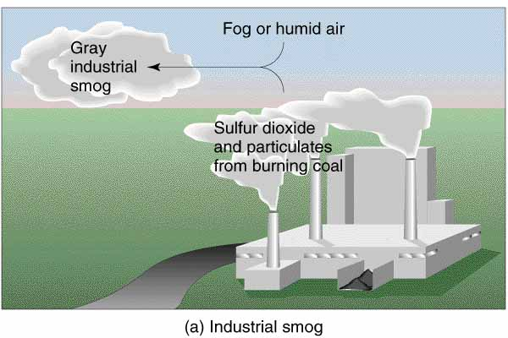

Outdoor air pollution tends to be reduced by precipitation (rain/snow) and wind (removal or dilution). Urban buildings, hills and mountains, and high temperatures tend to increase local levels of air pollution.

Air near the ground is more dense than the air above it. The cool air and the pollutants within it cannot rise. Thermal Inversion occur when air near the ground cannot be heated and remains in place allowing pollutants to build. The inversion layer traps emissions that then accumulate beneath it, which can cause pollution. Occurs in large cities with high concentrations of vehicle exhaust and industrial emissions.

Remember: A warm layer of air is trapped between two cold layers.
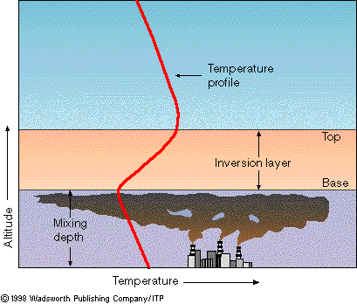

Acid Deposition
~any precipitation with a pH lower than 5.6~
Caused by: SO2 & NO2

Many power plants and smelters in developed countries use smokestacks to emit pollutants above inversion layers. This helps to dilute and remove pollution locally (wind) but increases regional air pollution downwind.
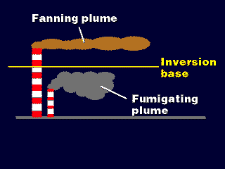

These pollutants frequently form secondary pollutants and are deposited hundreds of miles away from their source as acid rain.

Acid rain is typically 10X as acidic as natural precipitation but can be as high as 1,000 times greater.

Acid rain frequently crosses international borders causing political conflict.

Acid deposition causes respiratory disease, damage statues and buildings, and can impact on fisheries, forests, and farms.
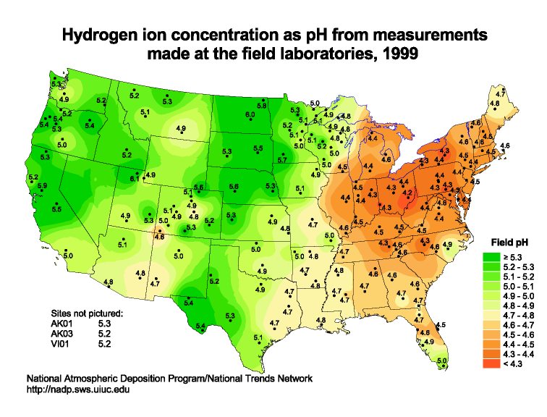

In aquatic systems damage to fish populations begins to occur when the pH falls below 6 (acid shock).
Plants are damaged in soils with pH below about 5.
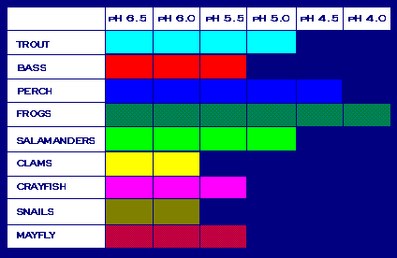
Most of the world’s lakes and forests are not being destroyed by acid rain because it tends to be a regional problem.
Acid Deposition can be reduced by reduce coal usage, burn low-sulfur coal, reduce nitrogen oxide emissions from cars, and increase the use of renewable resources.

Indoor Air Pollution (page 542)
Levels of indoor pollution are typically far worse than levels found outside. The effects of exposure to indoor pollution are further magnified because people tend to spend far more time inside than out.

The most dangerous indoor pollutants are: cigarette smoke, formaldehyde (common in the manufacture of many house hold materials), Carbon Monoxide, & radioactive radon gas (other parts of U.S.).

Radon gas is found in most soils and can seep into homes and damage lung tissue over long periods of exposure (the second leading cause of lung cancer).
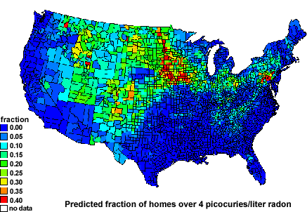

Asbestos was commonly used as a building material and has been shown to be responsible for several lung disorders. It continues to be used in many countries as an inexpensive building material.

Air Pollution on Living Organisms
Years of exposure to air pollutants can severely weaken the body’s natural defenses causing:

1. lung cancer
2. asthma (allergic reaction that leads to shortness of breath)
3. bronchitis (inflammation of the bronchi)
4. emphysema (damage to the air spaces of the lung)

Risk analysis is difficult to do on respiratory problems caused by air pollutants because of the variety of pollutants a person is exposed during the course of a lifetime.

Plants are affected either directly (loss of leaves i.e.) or indirectly (increased susceptibility to pests, disease, drought). Plants at high altitudes (typically conifers) suffer the most harm. Many crops are damaged by ozone reducing food production in the United States by 5-10%.

Sick building Syndrome is the buildup of toxic pollutants in an airtight space, seen in newer buildings. The EPA has identified 4 specific reasons for SBS: inadequate or faulty ventilation, chemical contamination from indoor sources, chemical contamination from outdoor sources, biological contamination from indoor or outdoor.

Preventing and Reducing Air Pollution
~use this opportunity to make a concept map~
p. 533

Several Clean Air Acts have been passed that establish air pollution regulations enforced by both federal and states.

National Air Ambient Air Quality (NAAQS) standards have been established by the FDA. Primary standards are used to protect human health while secondary standards were established to protect the environment and prevent property damage.

As a result, the level of many air pollutants has dropped substantially while detrimental health effects have been reduced.

Unfortunately, ozone and nitrogen oxide pollution continue to rise and approximately 142 million Americans still live in areas that have not met the primary standards set by the FDA.

Many environmentalists believe the following steps should be taken to reduce the impact of air pollution:
1. switch from pollution clean-up to prevention
2. increase fuel efficiency for cars
3. increase regulation on inefficient two-cycle engines
4. reduce emissions of greenhouse gases.

Market-place controls (emissions trading policy) have been enacted that have worked to reduce SO₂ emissions and may soon be enacted for other pollutants.

https://www.youtube.com/watch?v=TbU-cDLQ0Yw
Explanation of Cap and Trade

Reducing poverty in developing countries would also greatly reduce air pollution because these individuals make use of the most pollution-generating means of cooking and heating their homes.

Stratospheric Ozone DEPLETION!
The formation of ozone begins when an O2 molecule is split by UV-C radiation.

~Use this opportunity to complete the table comparing Stratospheric Ozone and Ground-level Ozone~

