The Human Population
Human Population Numbers
~Scientists Disagree on Earth’s carrying capacity~
Every 5 days, the human population increases by 1 million. 1.9 million births occur, and about 800,000 deaths occur.
However, it hasn’t always increased so rapidly. Up until about 400 years ago, population was “stable.” However, with sanitation improvement and agriculture output increasing, population increased.
Some scientist believe that we have already outgrown, or will outgrow, our supply of food, water, timber, fuel, and other resources that we rely on.
Other scientists believe that the Earth does not have a fixed carrying capacity. They state that the growing population of humans provides an increasing supply of intellect that leads to increasing amounts of innovation. In other words, humans can alter the earths carrying capacity with innovation and creativity.
Example: farming inventions. Farming was formerly done with hand plows, then oxen driven plows, now there are mechanical harvesters to increase production.
Many factors drive human population growth
In order to understand human population impact on the environment, we must first understand what drives human population.
Demography: the study of human populations and population trends
Demographer: a scientist in the field of demography
Changes in population size
Inputs vs. outputs
Immigration: the movement of people into a country or region, from another country or region.
Emigration: the movement of people out of a country or region.
When inputs exceed the output, the population is in surplus (positive);
Therefore, when outputs exceed the input, the population is in the negative.
Crude birth rate (CBR): the number of births per 1,000 individuals per year.
Crude death rate (CDR): the number of deaths per 1,000 individuals per year.
We do not factor in migration with global population number because no one is leaving Earth to live on Jupiter, right?
Global population growth rate = $\frac{[CBR-CDR]}{10}$
In 2014 there were 20 births and 8 deaths per 1,000 individuals.
Therefore…
To calculate the population growth for a single nation, we DO take immigration and emigration into account:
National population growth =
$$\frac{[\left(CBR+immigration\right)-\left(CDR+emigration\right)]}{10}$$
Doubling time: the number of years it takes for a population to double. Can be approximated with the “rule of 70”
Doubling time (years) = $\frac{70}{growth rate}$
Therefore, a population growing at 2 percent a year will double every ____ years.
This is independent of population size!
Fertility
Total fertility rate (TFR): an estimate of the average number of children that each woman in a population will bear throughout her childbearing years.
- For example, in 2014 the TFR in the US, of each woman was 1.9. This means that each woman in childbearing years gave birth to just under 2 children.
To gauge changes in population size, demographers also calculate the replacement-level fertility (the total fertility rate required to offset the average number of deaths in a population in order to maintain the current population).
This number is typically around 2 children.
In developed countries, countries with relatively high levels of industrialization and income, there is typically a replacement level of 2.
In developing countries, countries with relatively low levels of industrialization and income, a TFR greater than 2.1 is needed to achieve replacement-level fertility. It is higher in developing countries because mortality is higher among young people.
In a country where TFR is = to replacement-level fertility, and where immigration and emigration are =, a country’s population is stable.
A country with a TFR of less than 2.1 and no net increase from immigration, is likely to experience a population decrease because that country’s TFR is below replacement-level fertility.
In contrast, a country with a TFR of more than 2.1 and no net decrease from emigration is likely to experience population growth because that country’s TFR is above replacement-level fertility.

Life expectancy
The average number of years that an infant born in a particular country can be expected to live, given the current average life span and death rate in that country.
Infant mortality: the number of deaths of children under 1 year of age per 1,000 live births.
Child mortality: the number of deaths of children under age 5 per 1,000 live births.
*can vary within a country* WHY? Race, socioeconomic status, ethnicity, access to adequate nutrition and health care.

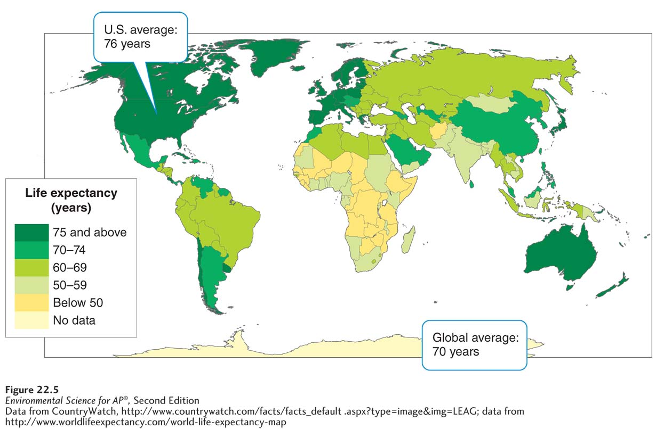

Aging and disease
Even with a high life expectancy and a low mortality rate a country can have a high crude death rate. The US has a higher CDR then Mexico.
Why?
Because the US has a higher elderly population than (13%) compared to Mexico (6% elderly population)
Disease is a limiting factor in human populations.
Today, AIDS-related illnesses kill more than 28 million adults and children. This is more than malaria or TB (formerly the two infectious diseases responsible for the highest number of deaths)
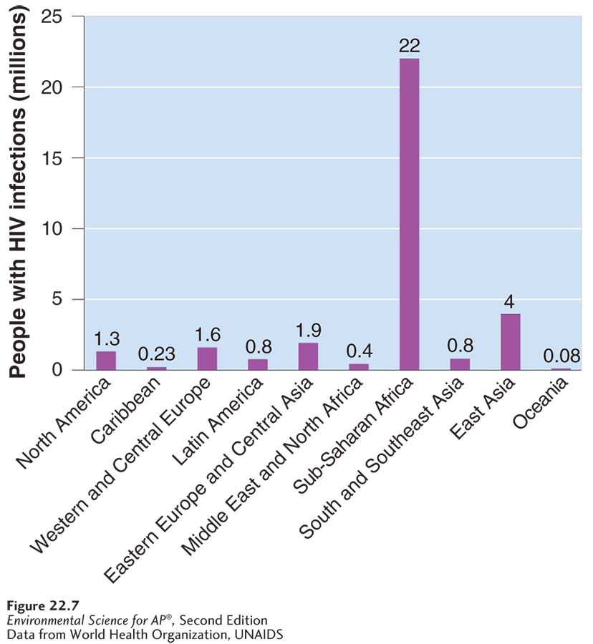

Migration
Net migration rate: the difference between immigration and emigration in a given year per 1,000 people in a country.
$$\frac{number of immigrants a year}{number of people in the population}$$
A positive net migration value will mean that there is more immigration than emigration.
Age Structure Diagrams describe how population are distributed across age ranges.
Age structure diagrams: a visual representation of the number of individuals within specific age groups for a country, typically expressed for males and females.
Population pyramid: an age structure diagram that is widest at the bottom and smallest at the top, typical of developing countries. (A)
Even distribution of ages: age structure diagrams with little differences between numbers of individuals in age groups are shaped more like a column. (B)
Inverted pyramid: a country with more older people than younger people will look like an upside down pyramid. (C and D)
Population momentum: continued population growth after growth reduction measures have been implemented.
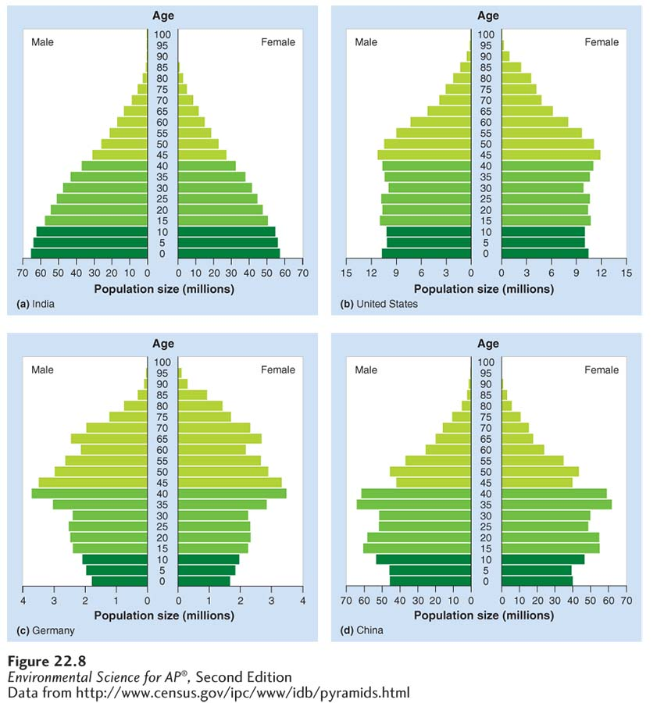

Economic development, consumption, and sustainability
Theory of demographic transition: the theory that as a country moves from a subsistence economy to industrialization and increased affluence it undergoes a predictable shift in population growth. 4 phases.
Affluence: the state of having plentiful wealth including the possession of money, goods, or property.
 | Phase I (Preindustrial) | Phase 2 (Transitional) | Phase 3 (Industrial) | Phase 4 (Postindustrial)
CBR and CDR Patterns | CBR &CDR are both high | CBR remains high, CDR begins to fall | CBR begins to fall, CDR continues to decrease | CBR is below CDR
Socioeconomic trends | -subsistence economy  -lack of medical care, sanitation, clean water | -increased access to food, health care, and sanitation  -lack of birth control education | -increased affluence and education  -declining birth rates | -high affluence and economic development.  -more elderly  -possible increase of birth rates
Impact on population growth | Zero population growth | High population growth | Stable population growth | Negative population growth

Family Planning: the practice of regulating the number of spacing of offspring through the use of birth control.
Kenya, Thailand, and China have all implemented effective family planning campaigns.
What are some reasons for the effective reduction in TFR? What are some possible concerns with government-led family planning campaigns?
All 3 made family planning accessible. Education efforts were put in effect for the public about the benefits of smaller family size and how to use birth control.
Ethical concerns include disregard of religious and cultural values, human rights violations could include forced sterilizations and infanticide of females. If a couple are permitted only one child, they may choose to abort a female fetus to ensure they have a male child to carry on the family name and traditions. This has led to a disproportionate amount of males.
Family planning also helps decrease STD’s and increases higher education. With less children, families are able to provide more education, medical care, and food. Poverty levels can decrease.
When women have the option to use family planning, crude birth rates tend to drop! Women who are educated, have a lower TFR.
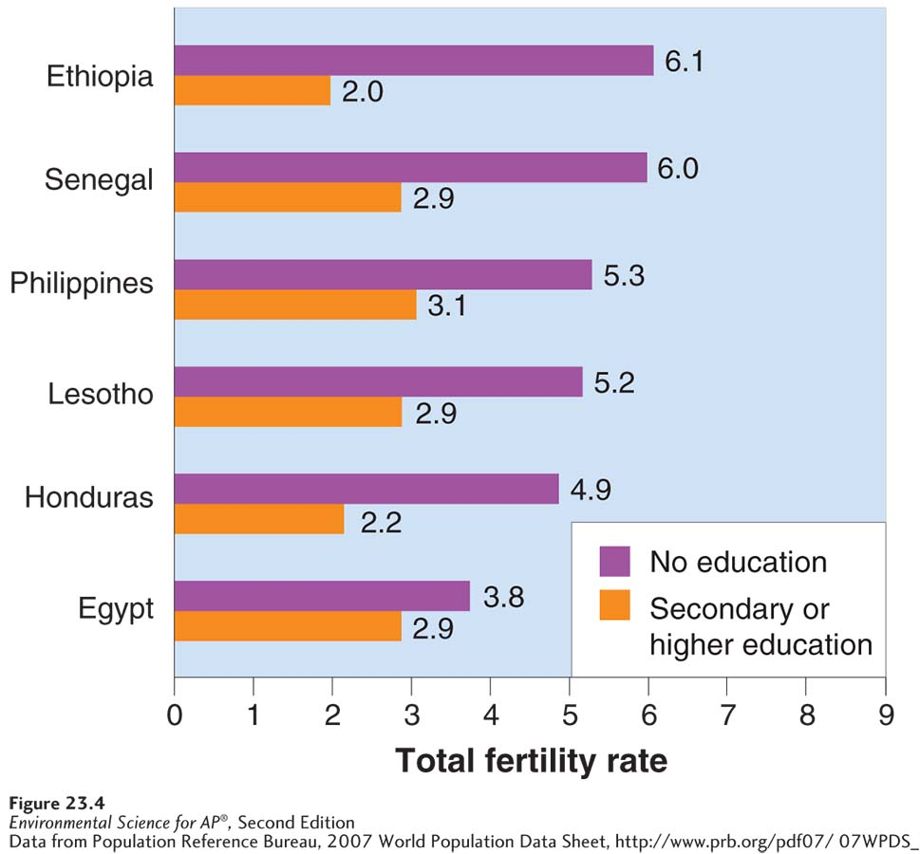

Population size, economic development, and consumption interact to influence the environment
Resource use
The world average ecological footprint is 2.1 ha (6.7 acres) per capita
The US has the largest of any nation at 9.0 ha (22 acres) per capita
Chinas footprint is 1.8 ha (4.5 acres) per capita.
Haiti’s footprint is .5 ha (1.2 acres) per capita.
In other words, the US has a footprint 5 times more than China and 18 times more than Haiti.
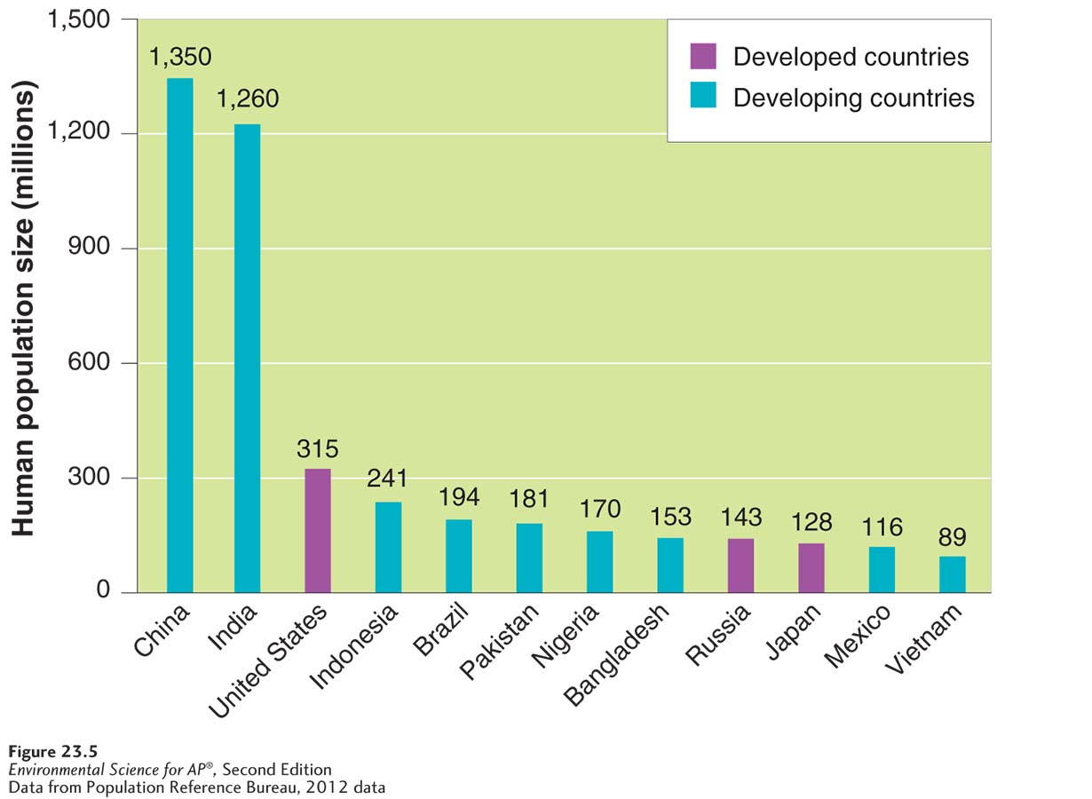

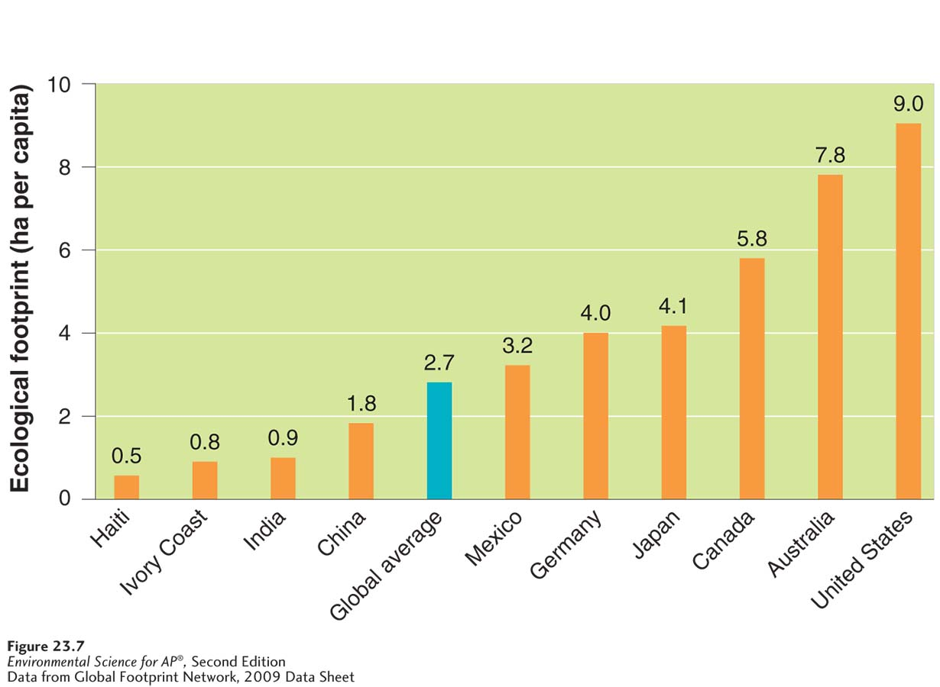
The IPAT Equation
An equation used to estimate the impact of the human lifestyle on the environment:
Impact = population X affluence X technology
This is a conceptual representation of the 3 major factors that influence environmental impact.
Population has a straightforward effect on impact. It stands to reason that the nation with the more people, has a larger impact (usually) two people consume twice as much as one; more people will have a greater impact on Earth.
Affluence: more wealth leads to greater consumption levels
Technology: destructive technology such as equipment that uses CFC’s can degrade the environment
Gross domestic product (GDP): a measure of the value of all products and services produced in one year in one country.
Increased wealth = higher pollution levels
With GDP increase, a turning point may be reached where a country can afford technologies that will prevent pollution and is able to implement environmental regulations that improve environmental quality.
- As GDP increases, a nation begins to be able to afford fossil fuels.
- This country may also rely on rudimentary, inefficient machinery.
GDP includes consumer spending, investments, government spending, and exports minus imports.
Local v. Global
Local impacts are typically more common in less developed nations where societies are agriculturally based. Local impacts include the overuse of resources within a region, such as overuse of land that results in deforestation and local water pollution. Global impacts are more common in affluent or urban societies because they use imported fossil fuels, food, and other resources.
How can a local become a global impact?
When a local action affects a global common good. Example, deforestation in brazil is a local impact because it leads to soil erosion and habitat loss. It becomes a global impact because forest removal means losing a carbon sink. Increased levels of atmospheric carbon lead to global climate change.
Urban area: an area that contains more than 385 people per square kilometer (1,000 people per square mile)
Concerns and benefits with living in an urban area?
Urban areas produce greater amounts of solid waste, pollution, and carbon dioxide; however they tend to have smaller ecological footprints because of greater access to public transportation and services. In less developed countries, affluent urban areas have safe drinking water, sanitation, and waste disposal. However, in less affluent urban areas of developing nations, the very poor often construct shantytowns that include unsafe dwellings that lack basic amenities (water and sanitation)

What is the difference between economic development and sustainable development?
Economic development focuses solely on meeting human needs and increasing prosperity.
Sustainable development focuses on meeting the essential needs of people without compromising the ability of future generations to meet their needs.
HW: p. 251, odd and 1 FRQ

