Chapter 3 “overview”
Matter: Anything that has mass and takes up space.
Atom: A basic unit of matter consisting of a dense, central nucleus surrounded by a cloud of negatively charged electrons.
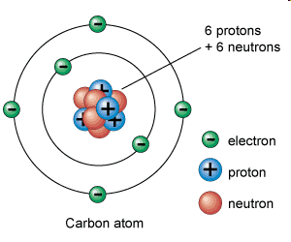
The Atomic Number of an element is the number of protons in the atoms nucleus.
The MASS number is the sum of the protons and the neutrons in the nucleus.
Atomic Mass= protons + neutrons
Element – A substance that is made entirely from one type of atom and cannot be further broken down into a simpler substance.
What is an electron? A negatively charged particle
Proton? A positively charged particle
Neutron? A NEUTRAL particle; has no electric charge.

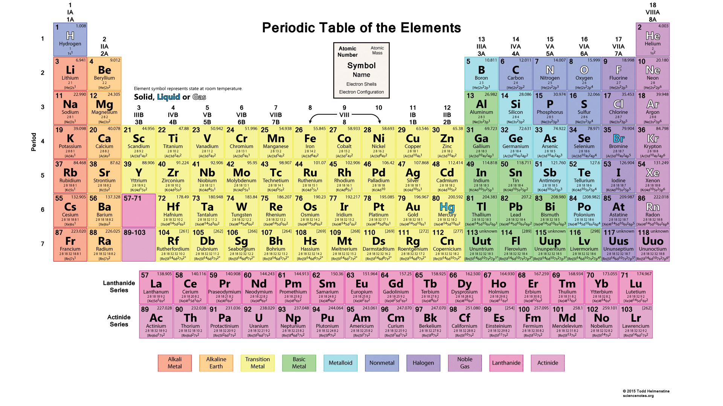
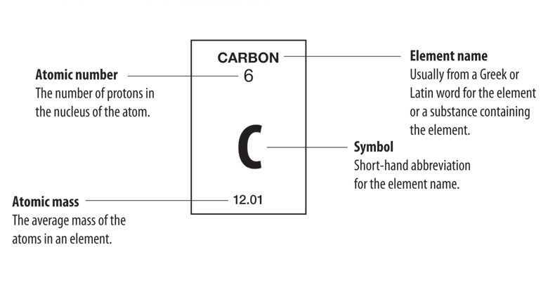
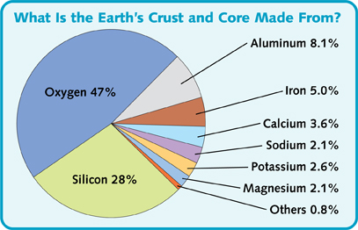

pH
What is an acid? A solution containing a substance that produces hydrogen ions (H+) in water. Anything below 7 on pH scale is considered acidic.
What is a base? A substance that produces hydroxide ions (OH-) in water. Anything above 7 on pH scale is considered basic.
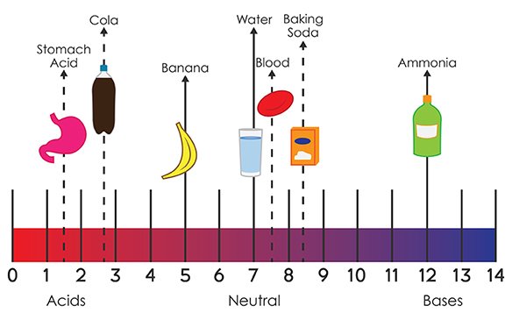

Find the pH of various chemicals and record them below:

States of matter
Solid: have a definite shape and volume; densely packed particles
Liquid: Definite volume, but not shape; take shape of container they are placed in
Gas: No definite shape or volume, unless restrained in a container.
Plasma: Ionized gas that emits electrons; very HOT.
Evaporation occurs when changing from a liquid to a gas. When any liquid reaches its boiling point, it vaporizes quickly to gas.
Condensation is the opposite of evaporation. When a gas is cooled to the boiling point, it becomes a liquid.
Sublimation is the change from a solid (ice crystals) to a gas (Water vapor) without an intermediate liquid state.

